Planning Committee members informal meeting with 2 representatives of Hannick Homes.

Thurs 25th January 2024. 7.30pm Council Offices, Butts Road, The public were able to attend this meeting but there were no public in attendance.

Present from the Council - Cllrs Ian Kearsey and Cllr Chris Rawlings. Clair Wilkinson, Clerk taking notes.
Representing Hannick Homes - Conor Lee and Chris Minors.

The council’s policy “Talking with Developers” was used as guidance before this meeting was approved.

The meeting was centred around the current progress Hannick Homes had made with a potential planning application for land on the corner of Hodson Road, shown in the map below.

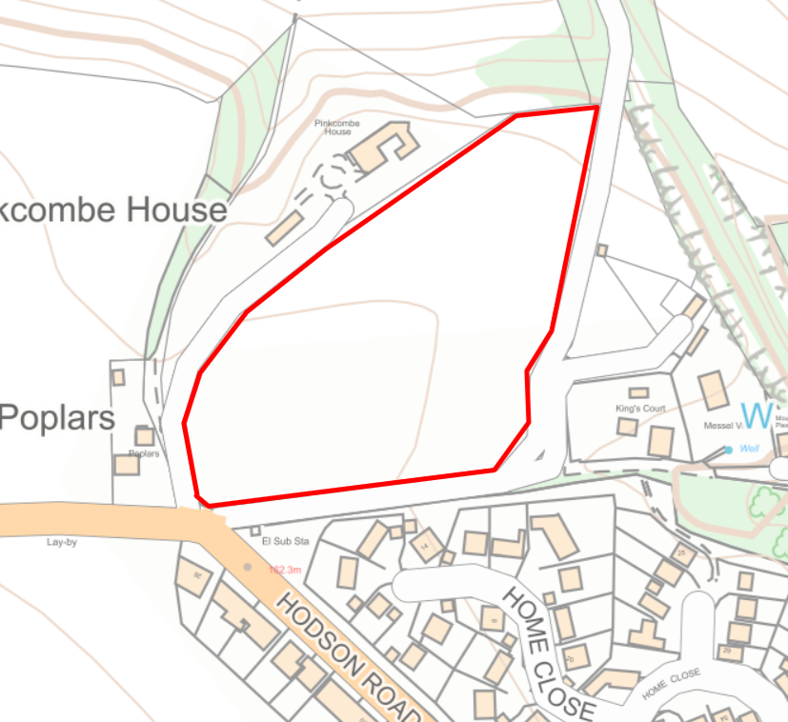

Hannick Homes approach to planning:
- Work collaboratively with councils and communities
- Want their work to have meaningful community benefit

- Wanted any new local development to be part of the Swindon Local Plan. However as SBC are currently re-drafting their plan with some delays, Hannick Homes have had to move forward. Also to note that the current draft of the Chiseldon NHP doesn’t have housing land allocation included.
- They would look to work to the draft “Design Codes” as part of the Chiseldon draft NHP documents.
- Proposed application would still be around 42 homes on site
- They need to do more work on the landscaping and ecology side of the plan.
- It will be a landscape led scheme
- Wont be high density housing levels but would not be as low density as Home Close for example.
- Looking at the Chiseldon NHP housing needs assessment, there is a desire for 2 and 3 bed homes. Their project will look to achieve this.
- The affordable housing requirement is 30%, which would equate to around 12/13 homes.
- Houses would be a maximum of 2 stories high with a mix of styles. Would look at Home Close as an example.
- Would be led by SBC on play area provision so CPC should look to influence SBC with this decision. Funds may be allocated as S106.
- With regards to the access of the site from Hodson Road. SBC are reluctant to approve mini-roundabouts. Hannick Homes would look at how they could introduce traffic calming measures at this area.
- They would create a new pavement from the edge of the site to the nearest bus stop on Hodson Road.
- They would be conforming to the Gov. nature recovery policies with 10% net gain. Could look at Washpool or other land owned by the landowner to the north of the site.
- The smaller roads in the development would be designed to look like shared driveways, perhaps using cobbles not tarmac. To encourage safe playing outside.
- Would be adding EV charging points.
- Need to look at how they would do a public consultation. They did gather public views on this area in 2018.
- Their next steps are to get the various reports they need from Highways and Ecology etc.
- They would then like to come back to PC for another discussion.

Meeting closed 20.04

