CHISELDON PARISH COUNCIL

MINUTES of the PLANNING, TRANSPORT DEVELOPMENT AND HIGHWAYS COMMITTEE MEETING
held on Thursday 26th August 2021 7.30pm Chiseldon Recreation Hall, off Norris Close. Chiseldon

Present: Councillors: Steve Duke (Committee Vice Chairman), Matt Harris, Danielle Simpson, Pauline Barnes. Also Clair Wilkinson (Clerk)
Apologies: Cllr Jefferies and Cllr Rawlings are on annual leave. Cllr Kearsey had a family commitment to attend to.

A proposal was made that these apologies be accepted. The proposal was seconded and all Cllrs were in favour.

21/69. Approval of Cllr Barnes joining the committee.

A proposal was made that Cllr Barnes join the committee. The proposal was seconded and all Cllrs were in favour.

21/70. Declarations of Interest. None

Public Recess: 4 members of the public.

2 members of the public wished to raise the issue of safety at the New Road/A346 junction. Turning right is a particular concern.
Cllrs shared this concern and it was noted that this item was on the agenda for discussion and vote.

2 members of the public raised an issue at Draycot Foliat where a contractors vehicle was parked on the carriage way near a bend in the road. The residents had some other comments that were either the remit of Swindon Borough Council or in hand with Ward Cllrs.
The resident raised several issues with the efficacy of the council and commented strongly about an individual councillor’s contribution in relation to matters not connected to Chiseldon PC and their remit of works in that area.
These 2 residents left the meeting after public recess concluded and 2 residents remained to listen to item 18 of the agenda.

21/71. Approval of minutes from 29th July 2021. No changes

A proposal was made to approve these minutes as an accurate reflection of the meeting. The proposal was seconded and all Cllrs were in favour.
21/72. Action points from previous meeting.

Owner | Minute | Action
Clerk | 20/60  20/61 | Chase contractor for update on quote for Draycot Foliat & Windmill Piece layby work. Awaiting for update on cost increase. STILL NO REPLY. CONCLUDED THAT CONTRACTOR NO LONGER APPLICABLE FOR THIS WORK. CLOSING THIS ACTION
 | 20/122 | Engage with SBC Highways on cost of removing the Build Out. NO UPDATE RECEIVED TO DATE
 | 21/06 | Add NHP consultants and NHP proposal to June full council meeting. Now July. Now August. ADDED FOR SEPT. COMPLETED ACTION
 | 21/14 | Work with Bancumm on drawing up designs for 2 sets of layby work. See 20/60. CLOSING ACTION – SEE ABOVE
 | 21/15 | Apply for SBC highways licence to install SID on New Road plus 2 further sites in Badbury. ONGOING. WAITING FOR SBC VERBAL APPROVAL
 | 21/30 | Talk to SBC Highways about sites for New Road SID. WAITING FEEDBACK
 | 21/21 | Talk to SBC Highways about sites for 2 Badbury SID sites WAITING FEEDBACK
 | 21/60 | Request more information on the planning app S/21/0326 revised, in order for the committee to make a decision. DONE. ON THIS AGENDA.
 | 21/63 | Add review of local plan document to Aug planning agenda and Sept full council agenda. DONE
 | 21/65 | Reply to SBC with CPC comments on the road safety consultation DONE
 | 21/66 | Work with Committee chairman on the purchase and install of 3 ground anchors to max £700.
 | 21/68 | SID locations at DF and Hodson added to Aug planning agenda DONE
 | 21/59  21/61  21/62 | Reply to SBC with committee decision on planning applications. DONE

Item 18 then moved to the next item of the agenda with Cllr agreement.
21/73. HIGHWAYS. Discuss & vote on request to SBC to consider traffic lights at the junction of the A346 with New Road in Chiseldon
The current situation at the junction was discussed.
A proposal was made to ask Ward Cllr Horley to request SBC Highways review the junction safety. To request traffic cameras temporarily installed to monitor speed and flow of traffic. Request that traffic lights be considered for the junction for the safety of motorists. The proposal was seconded and all Cllrs were in favour.
21/74. Consider and vote on budget items for committee for 2022/23 budget.
A proposal was made to request £1,000 for legal fees and £25,000 for parking improvement funds around the parish. The proposal was seconded and all Cllrs were in favour.
The Clerk will ask Ward Cllr Jefferies if she can request whether SBC can create the new Draycot Foliat and Windmill Piece layby’s the same way at the Norris Close layby’s were created.
21/75. Review budget vs expenditure report for April to July 2021
There were no comments or issues with this report.
21/76. PLANNING. S/21/1125. Burderop Park. Demolition of pavilions, change of use of offices, 25 apartment dwellings, 52 dwellings, access, assoc. works.
A proposal was made to reply with No Comment to this application. The proposal was seconded and all Cllrs were in favour.
21/77. PLANNING. Discuss & vote on S/21/1126 Burderop Park. 6 additional dwellings.
A proposal was made to reply with No Comment to this application. The proposal was seconded and all Cllrs were in favour.
21/78. PLANNING. Discuss & Vote on S/21/0326 Unicorn Business Park. Erection of 5 units.
A proposal was made to support this application providing access was maintained for HGV’s and Ridgeway Racing. The proposal was seconded and all Cllrs were in favour.
21/79. PLANNING. Discuss and vote on S/HOU/21/1047. Stocks Close. Badbury. Single storey side extension & porch to front. Render garage walls.
A proposal was made to make No Comment for this application. The proposal was seconded and all Cllrs were in favour.
21/80. PLANNING. Discuss and vote on S/HOU/21/1073. 10 Home Close. Detached summer house
A proposal was made to comment No Objection to this application. The proposal was seconded and all Cllrs were in favour.
21/81. PLANNING. Discuss and vote on S/HOU/21/1203. 10 Draycott Road. Pitched roof to garage and convert to habitable space.
Cllrs noted that this application would remove parking space from the property which does not correspond to SBC’s parking policy of 2 spaces per property.
Felt to also be incongruous with the street scene, and not appropriate in size for the plot size and host dwelling.
The Parish Council would ask if the applicant had considered extending into their garden space to not lose parking space. The Parish Council may be more amenable to approving an application where this was proposed.
A proposal was made to Object to this application for the reasons stated above. The proposal was seconded and all Cllrs were in favour.
21/82. PLANNING. Discussion and vote on S/21/0137. Draycot Farm. Change of use from agricultural to storage, distribution and offices.
There was concern over the amount of deliveries per week and the unsafe access for large vehicles to the site. The application does not provide enough information on how vehicles will arrive and depart the site to mitigate the SBC Sustainable transport plan. There are concerns over large vehicles on Draycot Close. There will be Highways and transport issues with access to the site. The vehicles will not suitable for the road size.
A proposal was made to Object to this application for the reasons stated above. The proposal was seconded and all Cllrs were in favour.
21/83. PLANNING. Discussion and vote on reply to SBC in regards to the Local Plan review documents.
Site map S0027 Policy LA22 related to Hodson Road Chiseldon.
A proposal was made to support this site remaining in the local plan review as a viable site. The proposal was seconded and all Cllrs were in favour.
The Clerk will also respond to SBC noting that a lot of the papers were dated 2019 still and had SBC considered their Open Spaces policy in relation to Covid19 and the extra use of local space this has created.
A second proposal was made to refer the final vote on this item to September Full Council with this committee’s recommendations on how to respond to the consultation. The proposal was seconded and all Cllrs were in favour.
21/84. HIGHWAYS. Discussion & vote on new sites for Speed Indicator devices at Hodson and Draycot Foliat.
The proposed sites were:
Hodson: On the road running through Hodson, at the Broome Manor end, just before the dip, facing down the hill.
Draycot Foliat: On the Draycot Close road, facing Ogbourne direction, just before the bend in the road and the parking layby.
See maps below:
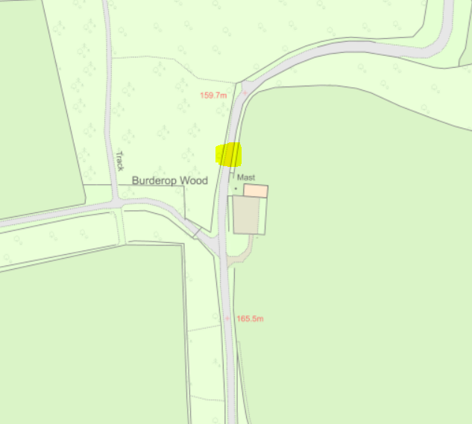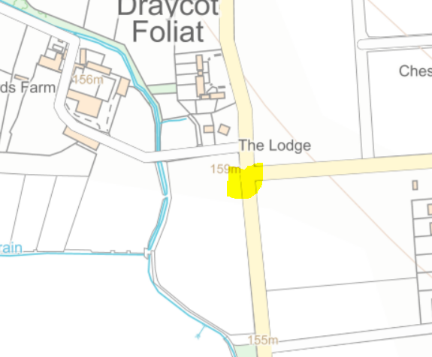
A proposal was made that these were the 2 sites to move forward with for new SID devices. The proposal was seconded and all Cllrs were in favour.
Clerk to add an item for the September agenda when the timescales for purchasing and installing the new SID’s is to be discussed and voted on.
21/85. TRANSPORT. No items.
21/86. Items for the next agenda. None.
Meeting closed at 20.55

Next meeting: Thursday 30th September 2021 7.30pm. Recreation Hall off Norris Close, Chiseldon.
ACTION POINTS
Owner | Minute | Action
Clerk | 20/122 | Engage with SBC Highways on cost of removing the Build Out.
 | 21/15 | Apply for SBC highways licence to install SID on New Road plus 2 further sites in Badbury.
 | 21/30 | Talk to SBC Highways about sites for New Road SID
 | 21/21 | Talk to SBC Highways about sites for 2 Badbury SID sites
 | 21/66 | Work with Committee chairman on the purchase and install of 3 ground anchors to max £700.
 | 21/73 | Ask Ward Cllr Horley to assist with the provision of traffic lights on New Road/A346. See minute item for details
 | 21/74 | Add request to Finance Committee for 2022/23 budget items
 | 21/74 | Ask Ward Cllr Jefferies if SBC can build the 2 required layby’s using the same procedures as the Norris Close layby.
 | 21/83 | Add to Sept Full Council agenda the final approve of comments to SBC for the Local Plan Review.
 | 21/84 | Add to next Planning agenda further discussions on 2 new proposed SID sites and purchases.
 | 21/76  21/77  21/78  21/79  21/80  21/81  21/82 | Reply to SBC with Committee vote on planning applications

