Chiseldon Parish Council

The Old Chapel, Butts Road, Chiseldon, Wilts SN4 0NW
 01793 740744
email: clerk@chiseldon-pc.gov.uk
Facebook page: Chiseldon Parish Council Notices
Website: www.chiseldon-pc.gov.uk

Talking to Developers Policy – Feb 2021
Review date Feb 2023

- Purpose.

Chiseldon Parish Council (CPC) acknowledge that developers may want to present proposals at different stages of the application process to seek the councils views. Pre-application discussions can play an important role in major developments. The Council welcome the desire of developers to consult with CPC and the local community. However CPC is also aware of the importance of public perception in planning and the need to avoid any appearance that CPC are conducting private negotiations or colluding with developers. In order to avoid improper lobbying by a developer or creating the impression that CPC has a pre-determined position on a proposed development, the council will follow the process below.

- Scope.

This document applies to all Parish Councillors, Committees, Employees of the Council, Contractual third parties and agents of the council who work and act on behalf of the council.
The document applies to all landowners, developers, and their employees and agents who act on their behalf.

- Procedure.

The developer must provide details of the proposed development they wish to discuss in writing to the council.
The developer must indicate specific information they wish to be kept confidential, with the reason why, in writing. The Council will keep a record of the confidential and non-confidential issues in writing.

Information held by CPC in relation to the proposed development is subject to disclosure by Data Protection and Freedom of Information legislation. This includes formal and informal communications.

Communications between developer and CPC both formal and informal do not tie CPC to any particular decision. Any views expressed are at best provisional as not all relevant information will be available to CPC and formal consultation has not yet taken place.

Open meetings of the council are open to the public (Section 1(1) Public Bodies (Admissions to Meetings) Act 1960 and developers may attend.
The developer may only speak during public recess of any such meeting unless the Chairman of the meeting suspends Standing Orders and allows the developer time to speak.

When an application decision is decided at a meeting, the council can decide if there are grounds to exclude the public. Section 1(2) Public Bodies (Admissions to Meetings) Act 1960.

The minutes of the meetings are available on the Councils website or via the Clerk on request.

The Council may invite representatives of the developers to attend a public meeting to discuss their application further.
It is an offence under Section 1 of the Bribery Act 2010 for a developer or their agent to promise to give financial or other advantage to a Parish Council with the expectation of improper consideration of a planning application.

- The National Planning Policy Framework – Last updated June 2019.

The NPPF encourages developers to liaise with the local planning authority (with NO specific reference to Parish Councils) before the submission of a planning application.

An extract of the NPPF states:

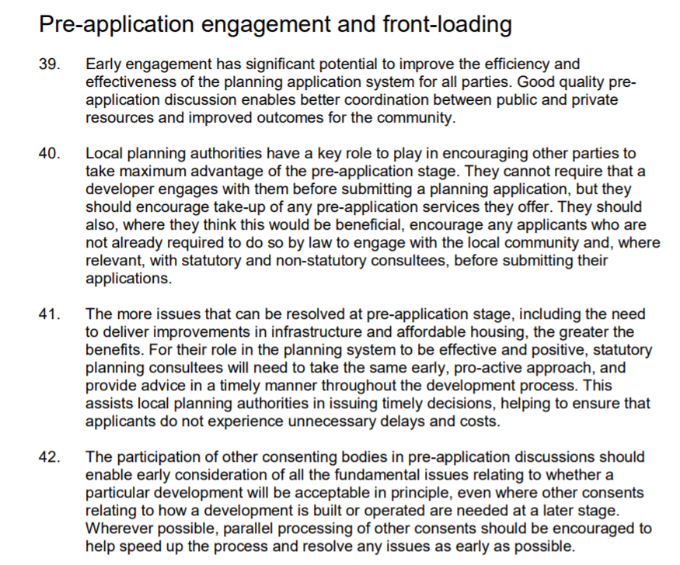

As highlighted above, there are circumstances where a developer may consult with CPC before the developer has submitted a planning application. The developer may also want to consult with a PC over any Neighbourhood Plan (NHP) that may be in place.
A NHP that is being drafted should also be publicised with its proposals and consult with certain bodies to ascertain their views on the proposals by the Parish before they are submitted to the planning authority.
It is anticipated that developers may wish to disclose proposed developments so that they may be accounted for in the proposals for a NHP.

Document Approved:8th Feb 2021 Minute Reference…20/187

Review period – 2 years

