CHISELDON PARISH COUNCIL

Contact details:
Clerk – 01793 740744 clerk@chiseldon-pc.gov.uk

You are summons to the Planning, Transport Development and Highways Committee
meeting remotely via MS Teams. Thursday 29th October 2020 at 7.30pm. Remote login details at the end of the agenda:

AGENDA

- Attendances and apologies for absence. Absence with no apologies to be recorded separately. Vote on approval of apologies.

- Declarations of Interest and vote on any dispensations required.

- Public Recess. 10 minutes maximum, 3 minutes per speaker if multiple speakers.

- Approval of minutes from 24th September 2020

- Action points.

7.  8.  9.  10.  11.  12.  13.  14.  15.  16.  17.  18. | PLANNING: VOTING ITEMS  Discuss & Vote on S/20/1234 Revised application  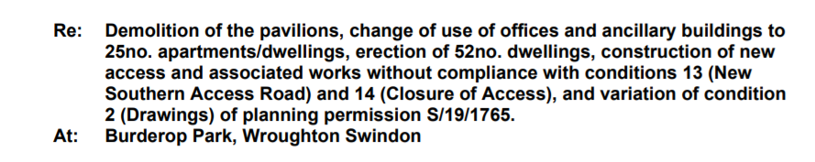  Discuss & Vote on S/20/1324 & S/LBC/20/1339 for the Listed Building aspect.  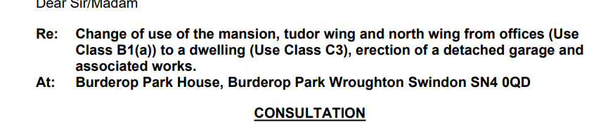  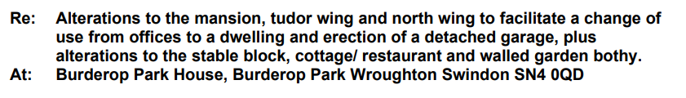  Discuss & vote on S/LBC/20/1295 The Manor, Badbury Lane, Badbury. New 1st floor and attic window.  Discuss & Vote on SO/HOU/20/1248 Frenshams, Turnball. Side and rear first floor extension.  Discuss & Vote on S/HOU/20/1199 Erection of first floor, 2 storey side, & single storey rear extension. Sevimli. 1A High Street. Chiseldon  Discussion & Vote on S/HOU/20/1316. 48 Station Road. Single storey front extension.  Discussion & vote on guidance document for Cllrs on replying to SBC on a planning application – see document loaded onto MS Teams  HIGHWAYS: VOTING ITEMS  Review of the pavement at The Canney in regards to the dip that will be a hazard in icy weather – see additional information  Discuss & vote on plans for a consultation with local residents of the New Road/Canney Close area on the Build Out. See additional information  Discuss and vote on plans to formally write to SBC in regards to overgrown New Road hedges and potholes. (Item requested by Cllr Rawlings)  TRANSPORT: VOTING ITEMS  No items  Items for next agenda  (Note, these items cannot be voted on at this meeting)
Next meeting 26th November 2020 – please note this is a change to the original published date.
Signed: C Wilkinson (Clerk) 21.10.2020

Committee members: Cllr Matt Harris, Cllr Chris Rawlings, Cllr Ian Kearsey (Committee Chairman), Cllr Keith Bates, Cllr Steve Duke, Cllr D Rogers, Cllr A Rogers.

LAW THAT ALLOWS THE COUNCIL TO VOTE/ACT:
TO FOLLOW

Login details:

https://teams.microsoft.com/l/meetup-join/19%3ameeting_NDhiZmM0NWUtODNjMi00NzlhLTg3ZmMtOTU3M2NiNDFmYjBm%40thread.v2/0?context=%7b%22Tid%22%3a%22994eb4e1-2fcb-47f9-a34e-66c6767624a1%22%2c%22Oid%22%3a%22abfe080e-0d86-401d-95dd-e231c117cc34%22%7d

