# *Chiseldon Parish Council*

The Old Chapel, Butts Road, Chiseldon, Wilts SN4 0NW

 01793 740744

email: [clerk@chiseldon-pc.gov.uk](mailto:clerk@chiseldon-pc.gov.uk)

Facebook – Chiseldon Parish Council Notices

website: [www.chiseldon-pc.gov.uk](http://www.chiseldon-pc.gov.uk)



**21st September 2020 EGPA meeting, additional information.**

**Item 7. Swindon Ladies Football Club discussion**

The club are no longer using the pitch as they have moved to an indoor 3G pitch for winter. Discussion on fees for practice sessions needed for August 2020, plus next season.

Currently invoiced at standard pitch hire fee for matches of £40.00 Can we offer them a discount for practice sessions both on the August invoice and for 2021/22 season. Note – CFC do not pay for practice sessions, they only pay match fees. Currently SLFC would only use the Rec field for practice matches.

**Item 9. Planting at Millenium Wood**

There is currently approximately £250.00 in the 2020/21 budget for the village planters. Does the committee approve funds from this to be spent on bulbs/shrubs?

Value of expenditure to be approved by committee

**Item 10 – Dog waste bag dispensers at dog bins**

September update:

The Facebook public consultation was not in favour of spending funds on these dispensers. There were comments that more bins for dog waste are always welcome. There were a few comments in regards to the following type of dispenser being created and kept stocked.



Can we ask the Guides/Scouts to create a number of these and use a portion of the rubbish bins replacement/additions budget to keep them stocked with bags as a trial?

Committee to discuss and vote on what expenditure to approve for purchasing of poo bags for these dispenseers. To go to Full Council if approved as no 2020/21 budget for this.

August 2020 original agenda info for reference.

Does the PC consider these for future budgets? Do we purchase one now to see how they are received/used?

Example:

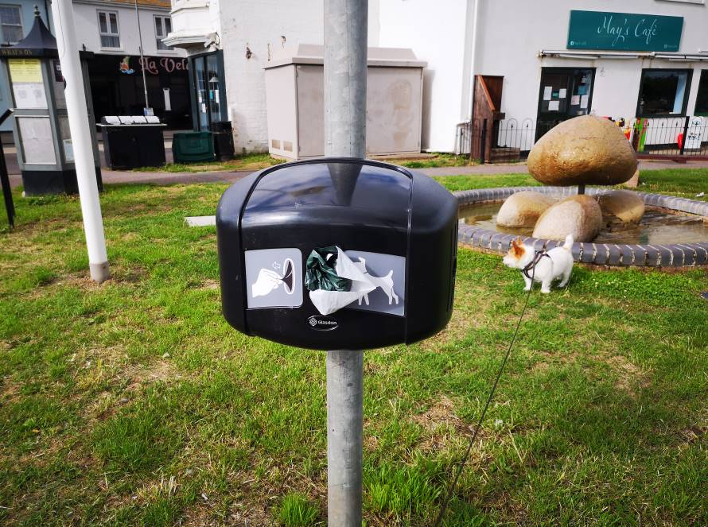

Costs £109.87 inc VAT & delivery from Glasdon. (other suppliers available)

1000 biodegradable bags are £39.77 inc VAT plus delivery.

**Item 11. Bench for Millennium Wood – old bench removed as rotten.**

There are a number of options saved on Ms Teams for the committee to consider. There are no funds in the 2020/21 budget for this so would need to go to Full Council for approval.

Costs will also be needed for a concrete base for the bench legs. Approx £150.

Recommend that committee approve their bench of choice and delegate authority to the Clerk for installation to a max additional value of £200.

**Item 15. Allotment lease increase for 2021/22.**

The allotments and small holdings act only allows lease increases with 12 months notice. To increase for 2021/22 we would need to advise allotment holders in the 2020/21 renewal document which is due out in Nov 2020.

**Current prices are:**

|  |  |
| --- | --- |
| Scale of charges – 2019/20 £ |  |
| Full plot | 27.50 |
| Half plot | 13.75 |
| *Concessionary rates for pensioners:* |  |
| Full plot | 16.50 |
| Half plot | 8.25 |

Committee to consider & vote on any increases for 2021/22.

**Item 16. Allotment breaches of tenancy agreements over weed control.**

**Plot 12A.**

On 29th July plot holder 12A was written to and reminded to keep weeds under control on the plot.

This is a photo of the plot last week:

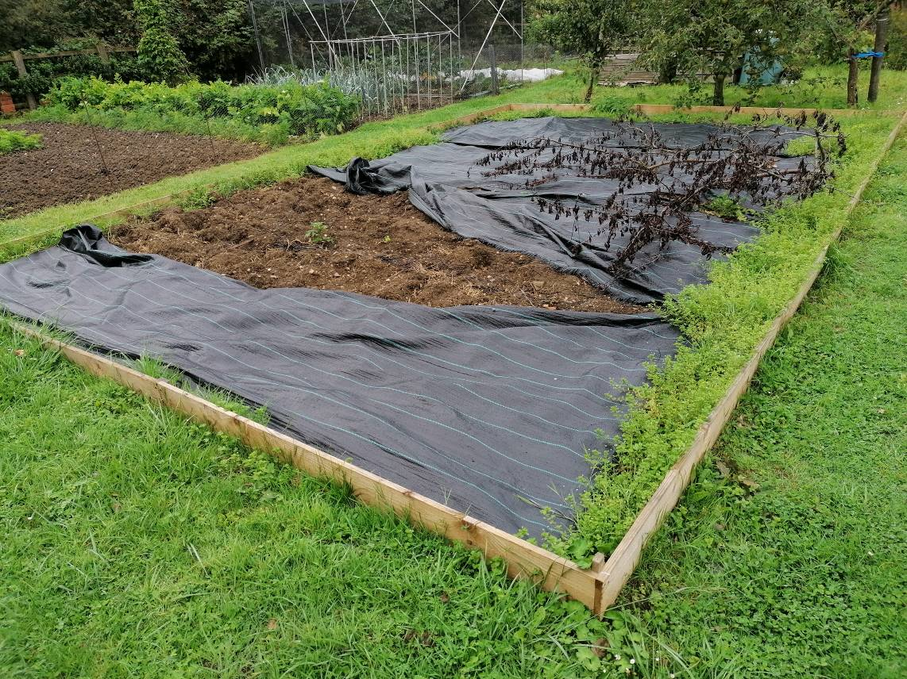

Proposal to give tenant 4 weeks notice to deal with the weeds that are not covered by the weed membrane or have their tenancy terminated. Committee to discuss and vote.

**Plot 12B.**

The plot holder was written to on 29th July with the following:**“*Review of Allotment:***

*The Parish Council have recently undertaken a review of the allotments and understand the affect the COVID-19 lockdown period has had on some tenants, limiting their ability to attend their plots over the last few months.*

*From 1st August, the government will pause shielding unless the transmission of COVID-19 in the community starts to rise significantly. From that date, all plots are expected to be worked and tenants have 4 weeks to show suitable improvement. If suitable improvements are not made by* ***Sunday 30th August*** *the committee will vote to terminate tenancy with immediate effect.*

*Please can we also remind all plot holders that the grass walk ways are to be kept cut short at all times and weed growth needs to be kept to a minimum to avoid the spread of weeds to neighbouring plots. Bonfires are to be attended at all times and please ensure smoke does not carry into neighbouring properties.”*

Photo of 12B from last week:

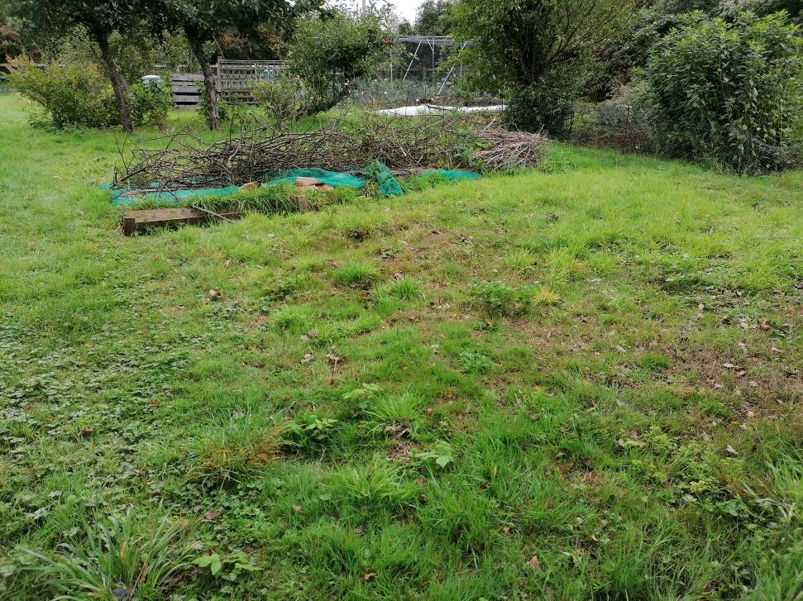

Proposal to terminate tenancy with immediate effect. Committee to discuss and vote.

We have 7 people on the waiting list for an allotment.

**Item 17. Request from allotment plot 9B to cut down apple trees on their plot.**

The plot holder has requested if they can cut down the appe trees on their plot themselves.

Currently the lease agreeement says:

*“Where a tree is in existence on a tenants plot at the start of a tenancy, the tenant takes responsibility for trimming the tree to keep it away from other plots to ensure it does not interfere with sunlight on other plots, using hand tools at ground level. Where a tree requires further intensive trimming, the plot holder should make their request in writing to the Parish Council who will assess the situation and act accordingly with professional advice.”*

The council needs to consider and vote on this request. Insurance liability should be considered.

The same trees were professionally trimmed in Feb 2018 by Morgan Trees costing £160.00

The Administration Officers also requests an addition to future leases:

*“If a plot holder wishes to have any trees removed, they should make their request in writing to the Parish Council upon which they will either need to supply a self-funded quote for tree removal or state if they will be removing themselves. Tenants removing trees themselves will be liable should any damage be caused.”*

To be considered and voted on by the committee.

**Item 19. Further pitch improvement work for Recreation Field.**

There is still £3575 in allocated reserves for pitch improvement work which needs to be spent.

The funds could be spent with Merretts who did the original improvement work and are currently working with the football club on improvements to the pitches. The other suggestion from the football club is the purchasing of either portable dugouts to be stored in the gated area or the building of brick dugouts.

They estimate brick dugouts cost around £2000 and have also provided a link to a suitable portable style dug out.

<https://www.networldsports.co.uk/football/football-team-shelters-dugouts/forza-alu60-team-shelters.html>

These are more costly so funds would need to be raised by the club or by looking for grants.

1 x 4 seat shelter on wheels would be £2089.99 plus £229.94 delivery.

CPC could commit to providing £3575 to fund 2 shelters if CFC provided the rest of the funds themselves.

Approximate £832 shortfall for the club to provide.

**Item 22. New CVPA equipment. No vote needed.**

Preliminary information compiled by Administration Officer:

*Note – there is £12000 in the current financial years budget for this work.*

Here is a summary of what we have been quoted so far, for the new centrepiece at CVPA. I have not included the actual quote prices, but indicated roughly where they sit vs. budget. If you do want the prices, let me know and I will forward the quotes on to you.

**SOVEREIGN – 3 OPTIONS**

All quotes include the removal of the current play equipment in the centre. The removal costs are itemised and can be compared to the stand alone removal costs quote provided by Allbuild and CPC can choose either one do that piece of work.

One item is significantly under £12k budget, one is over budget and one is significantly over budget.



**MANT LEISURE – 4 OPTIONS**

Here are the options we have from Mant Leisure – again all quotes include removal of current play equipment but are itemised and can be subbed if required. One item is just below £12k budget, one is slightly over budget and two are over budget but give an indication of what is available, if there is an appetite to find the gap in funding.

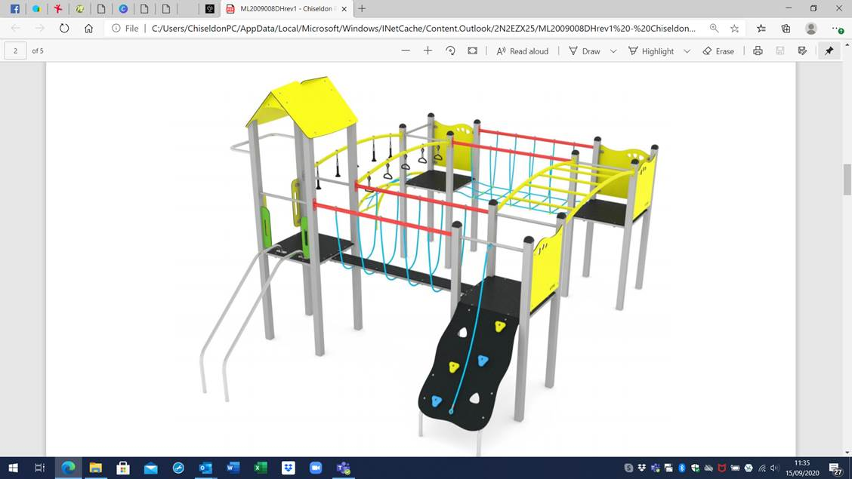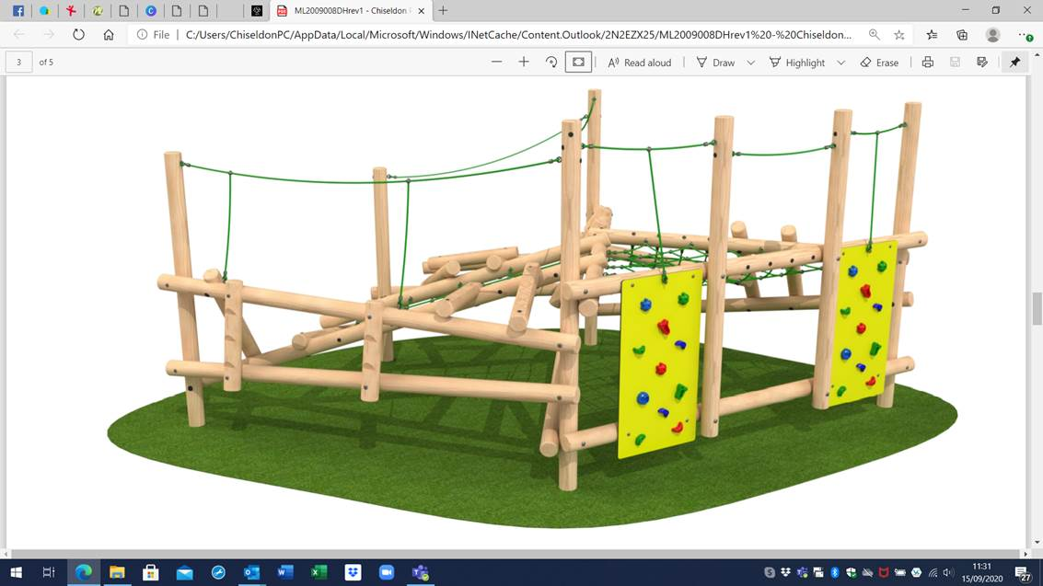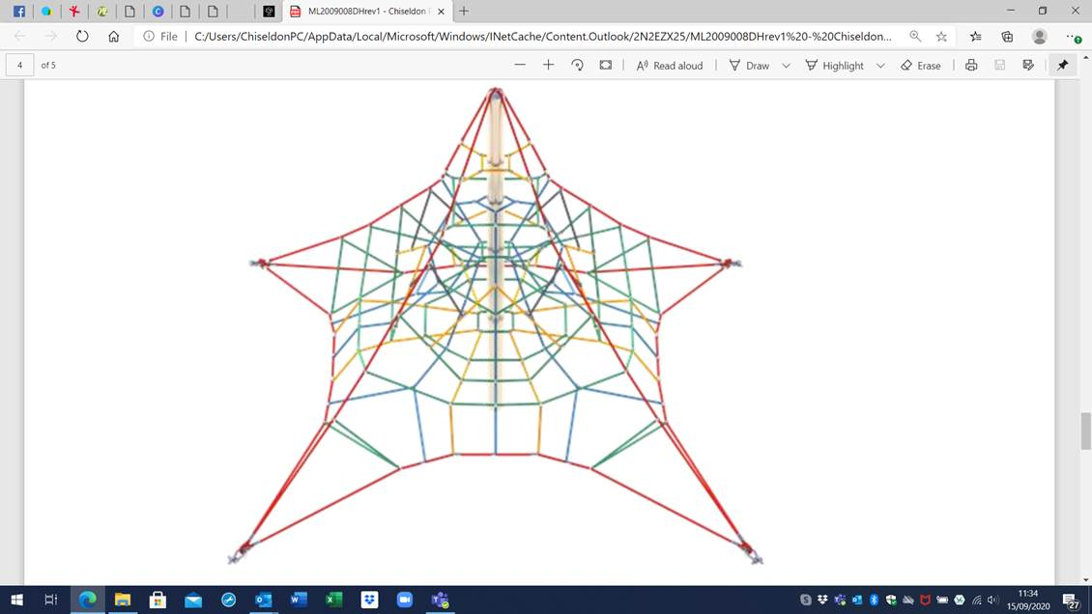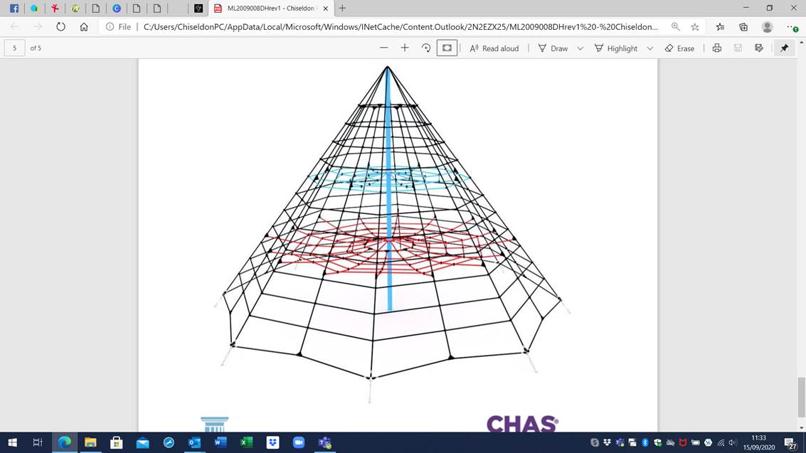

**OUTDOOR PLAY SOUTH WEST – 2 OPTIONS**

I’ve just received the final quote back from Outdoor Play South West. One option is just below budget and one is significantly under (£2k+) – apparently this is because the grass matting safety surface will only protect from a maximum fall height of 3m and they cannot install a larger version without a significant increase in the price of surfacing which would blow the budget.

These quotes both include itemised removal costs of the current equipment in place. One other note of interest is this company recommended installing steel feet for the clamber stack and have quoted for it – I’ve inserted a screen shot with info below.

I don’t think we have any product dimensions for the Mant Leisure quotes other than the height of the rope equipment, I’ve asked for those so we can gauge the size. If there is anything else you think would be useful/you need, let me know.

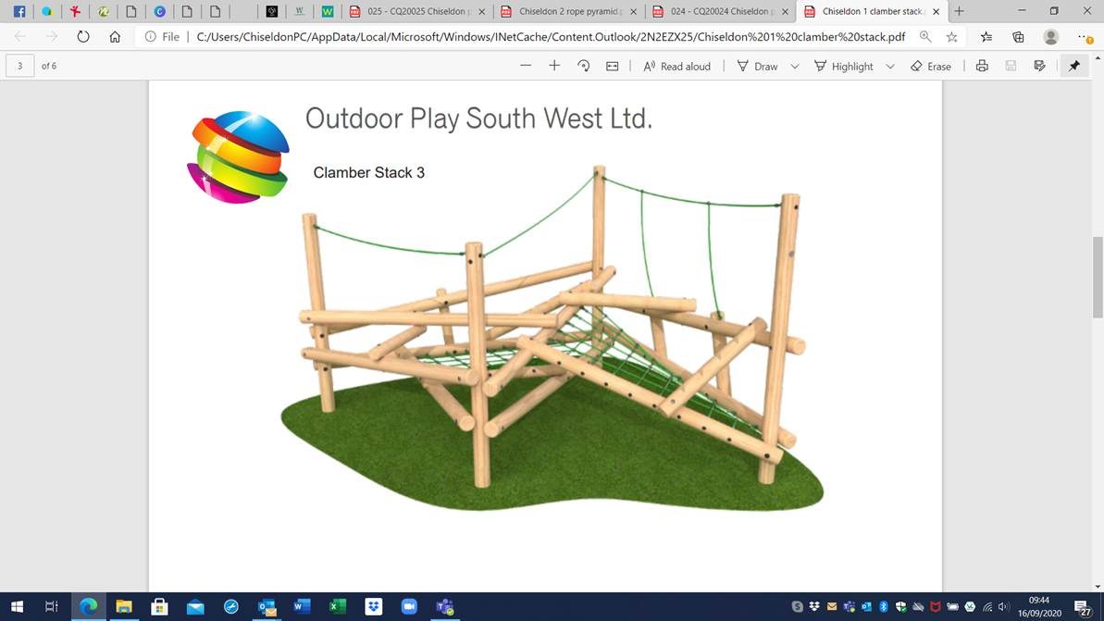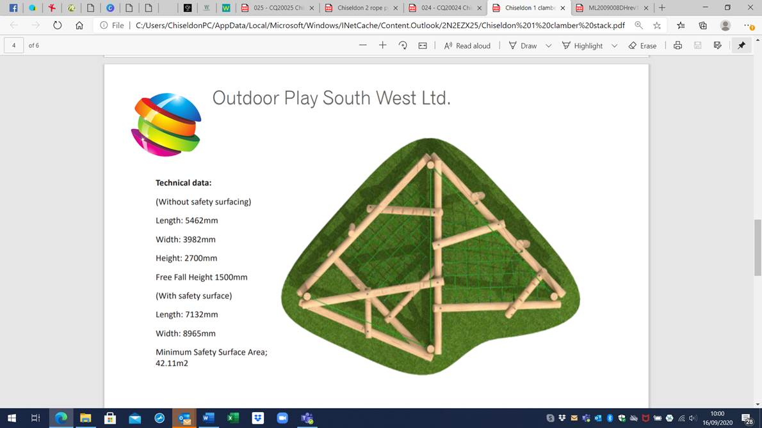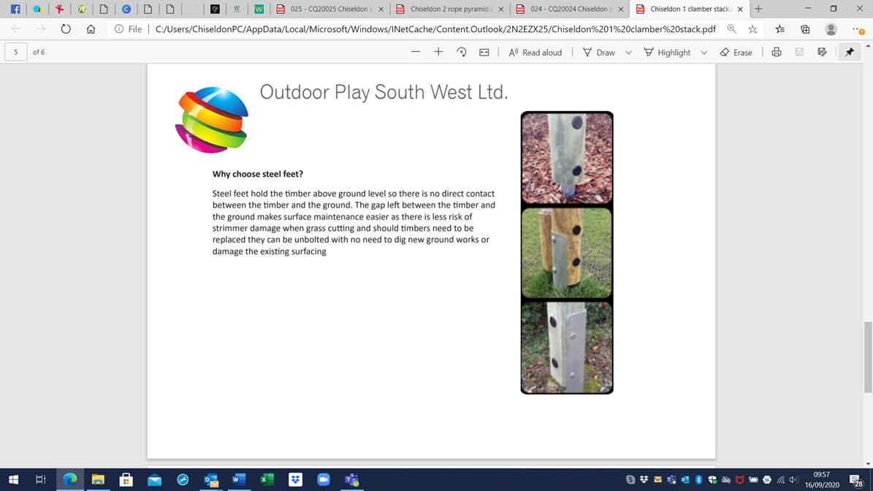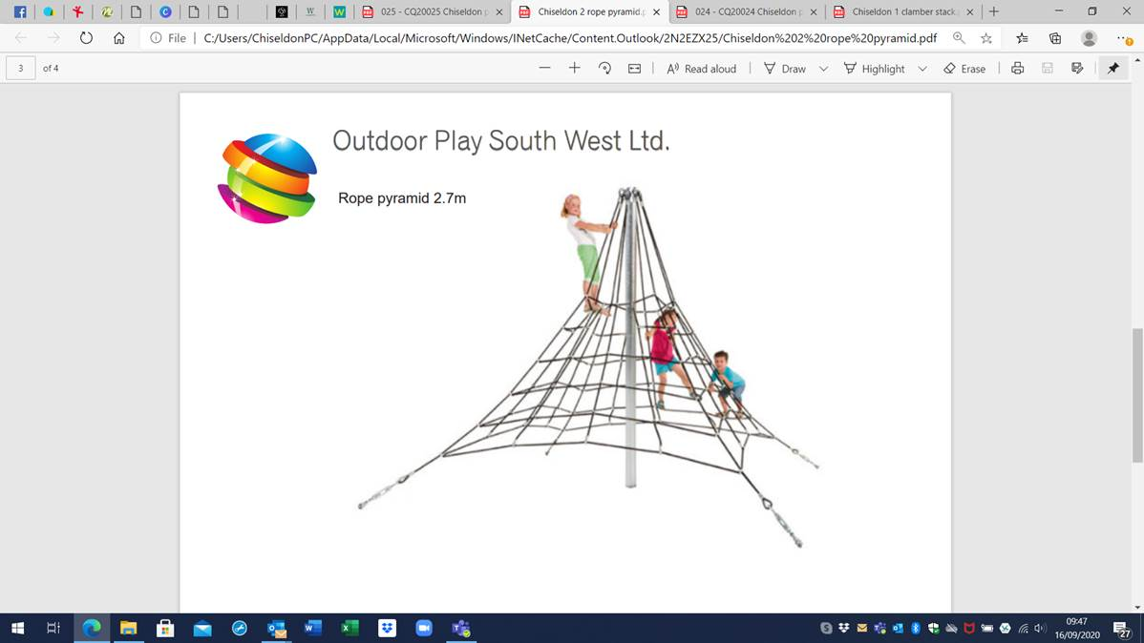

We will have one further quote for comparison for Octobers EGPA agenda.

**Currently only require feedback from the committee as to what type of equipment to consider from the above options.**

More specific options can then be brought back to the October meeting.

**Item 23. Whether to keep the Castle View Play area open.**

Clerk to report on visual checks on maximum of 6 people from the past week.

Signage has been erected to reminder user of 6 max at any one time.

Committee to discuss and vote on whether to leave the area open with max. 6 numbers at any one time, or to close the area. Can be reviewed monthly.

**Item 25. Creation of new sub committee for bmx/pump track.**

EGPA Committee to decide:

* If to form this sub committee
* Members of the sub committee
* Scope of responsibility & decision making powers of the sub committee
* Terms of Reference of the sub committee
* When they meet
* How they report back to the EGPA committee

The agreement to form the sub-committee and the members can be voted on in the Sept EGPA meeting. Suggest that the sub committee create a document showing their responsibilities & decision making powers, terms of reference, meeting frequency and reporting methods back to EGPA for the October EGPA meeting to approve.

See information relating to sub-committees in Files section of EGPA MS Teams.