Chiseldon Parish Council

The Old Chapel, Butts Road, Chiseldon, Wilts SN4 0NW
 01793 740744
email: clerk@chiseldon-pc.gov.uk
website: www.chiseldon-pc.gov.uk

13th July 2020 full council meeting, additional information

Item 1. Co-option of Cllrs

Jillian Robertson.
My reasons for wanting to become a Parish Councillor are that I have lived in this village for the last circa 20 years and am committed to its future. I believe the village does need to adapt and change however I feel that passionately that this should be done in light of ensuring that the wishes of the villagers are taken into account as its important to ensure a harmonious environment in which we all can live.

I would be a good Councillor because I will bring a lot of the skills from my work background – I’m a qualified Chartered Management Accountant with an MBA (Corporate Finance) and have experience of significant people leadership. I have had to lead large numbers of people (circa 1000 engineers) when I worked for Openreach and have experience on how to deliver results whilst also engaging with my teams to take them with me on that journey therefore I have vast people and stakeholder management skills which I feel will be vital as a Councillor.

My business background and professional qualification mean that I have significant negotiation and influencing skills that I will bring to the role.

Overall, I would like to be considered for a Parish Councillor vacancy because I feel that I can use my skills and background to best effect to ensure the best future and outcome for all residents in Chiseldon Parish.

Item 9 – Amended Standing Orders. See document attached to this email.

Item 11. Safe opening of Castle View Play Area (CVPA) and approval of funds to facilitate this.

Other local parishes plans are: (For information only)

Quotes from Clerks:
“Our handyman is going to clean the play equipment prior to opening and then once a week.. I am then going to make this clear on the signage.
I have purchased a manual pressure cleaner for him to use, he also has wipes for "high touch" areas.
It will be impossible to clean after every use so we are going to have to rely on users using hand sanitiser as much as possible.”
-------
“The area has continued to have safety inspections on a fortnightly basis throughout lockdown so the area will be opened on Saturday morning. They will not be undertaking any cleaning, a sign is going to be put up about the need for social distancing and hand hygiene and the regular use of hand sanitiser. There is a new Councillor on the council, who is probably early 30’s with young children and her view was ‘I am responsible for my children’s health’ and she was quite clear in that it was up to her to ensure that their hands were appropriately cleaned. Also, cleaning the equipment is only good at the time of doing it as it only takes one person to leave the virus. We do not have a handyman or any maintenance staff, so it would be down to one of the Councillors to do any cleaning.”

-------
“A full safety inspection will be carried out on all 3 areas on Friday morning and the areas cleaned and tidied. Padlocks, chains, hazard tape and signs will be removed on Saturday morning. New signs about social distancing etc will be put up. The wording on the signs has been taken from ROSPA and the Police. It encourages people to take responsibility for themselves. There will also be a Facebook post to back up the message and encourage responsible disposal of antibacterial wipes and disposable face masks. The post will make it clear that the area is not being disinfected. I understand that one Parish Council will be saying that ‘the equipment is used at your own risk’. I don’t believe that those words can be used as ultimately the Councils are liable and the onus is on them to prove that they have taken all reasonable steps to mitigate any hazards and risks.

We will also be reserving the right to close the areas down again if things get out of hand and/or the amount of hazardous litter becomes unacceptable! “
----
“We are cleaning, doing specific safety risk assessments, and enough signage to explain what they should and shouldn’t do, in line with most recent government advice. We may delay opening some (24 to get round) until we’re ready. I’ve given the team authority to keep a piece of equipment closed if they’re unsure about the safety.

We have received some guidance from our insurers which is quite useful too. But at the end of the day, families need to take responsibility for their own actions.”
I have received a Covid19 Risk Assessment document that we can use in the event of opening CVPA – attached to this email for info.
Our insurers have sent the following advice:
Playgrounds
Whilst we are unable to advise whether specific measures are acceptable to comply with Government guidelines, we can advise what the insurance requirements are. Therefore I can confirm, the policy we arrange requires reasonable steps to be taken to prevent or protect against injury, illness, loss or damage arising. Provided such steps are in place and subject to all other policy terms and conditions being met, the policy will respond should a claim arise and the Council is found legally liable.

The National Association of Local Councils (NALC) have published recent advice in regards to opening various facilities including play areas which will help Councils in this situation, in addition to their expectations on users (and/or their parents) of the facilities; https://www.nalc.gov.uk/

The insurers have not issued any specific guidance on managing the risk of Covid-19 in regards to play areas or outdoor gyms. Whilst a revised risk assessment should be undertaken to take into account Covid-19, for further advice or guidance we recommend that you contact the consultants who undertake the annual inspection of the play/outdoor gym equipment. It is important that playgrounds are suitably safe for use and have an effective inspection and maintenance regime in place prior to opening. NALC have advised to support local councils using the Risk assessment for COVID-19 guide – the templates for council reopening checklist and general workplace risk assessment have been made editable.

We expect that playgrounds will be very heavily used, especially with the warm weather that the summer months bring and the eagerness of the public to start using them again, so it is vital that playgrounds are thoroughly inspected to ensure a satisfactory level of safety is in place. You also have a responsibility to remove any temporary barriers that may have been put up during lockdown which may also be hazardous.
You may find the following article from the RPII a useful reference point for further guidance https://www.playinspectors.com/news/statement-on-the-governments-announcement-on-the-reopening-of-outdoor-playgrounds-on-july-4th-2020/
You may also find the link to the summary from the API and additional guide for you: https://www.api-play.org/wp-content/uploads/sites/4/2020/07/APIStatementFinal.pdf

(RPII – Register of Play Inspectors International)
If we are to open I would propose:
- Quarterly safety inspection check from The Play Inspection company before opening.
- Bins to be emptied 3 times a week by Allbuild – the cost per empty is £2.75. There are 2 bins in this area.
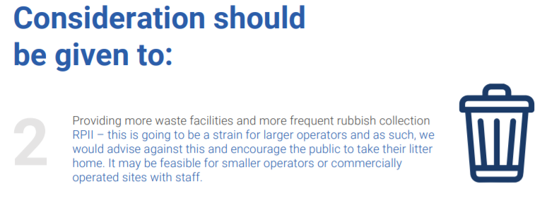
- Remove one swing from each frame to ensure social distancing when on this equipment
- Tie the ropes up and away from use on the wooden trail as this piece of equipment does not facilitate 2 meter social distancing.
- Mark balance beams with 2 meter sections using tape to identify 2 meter spacing.
- Prevent benches from being used as these as not essential equipment and are another contamination site. Can only use tape/rope to achieve this and isn’t tamper proof. Signage to be provided.
- Can consider locking the 2 gates in an open position as they will be high touch areas – parents to be advised to suitably supervise small children via signage.
- Operate a one way in and out system through the 2 gated entrance/exit points.
- Limit visits to one adult per family group and limit number of people within the site at any one time. Stating the maximum advisory numbers permitted.
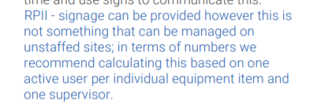
This would mean 16 users max for CVPA.
- Allbuild can disinfect the site using a pump action sprayer with a misting tool plus appropriate disinfectant. They would charge £30 per hour for this service. The Council can decide on the frequency of this cleaning.
- Plentiful signs up covering social distancing, hand washing and sanitising and other required information. Laminated signs to start but will look at signs being printed for a more long term solution. I have seen useful 2 meter banner signs which detail all the information and show how far 2 meters is.
- Carry out twice weekly Risk Assessments of the site for Covid19 requirements. I am happy to do this. Suitable PPE to be purchased.
- Proposal to not allow our Handyman on to site for anything less than urgent work to ensure his safety.
- Reserve the right to close CVPA if rules are not followed or litter becomes excessive. It is an extra danger to staff, contractors and visitors if there is excess rubbish not disposed of correctly.
- Review at each Full Council meeting until restrictions are lifted. Also review at Full Council when rules are changed. (relaxed or tightened)
- Clerk to be given delegated powers with Chairman, Vice Chairman and EGPA Chairman to make emergency decisions based on H&S of the site and its users.
I believe this should be handled at Full Council and not EGPA decision as the council as a whole need to be aware of the liabilities of this action.

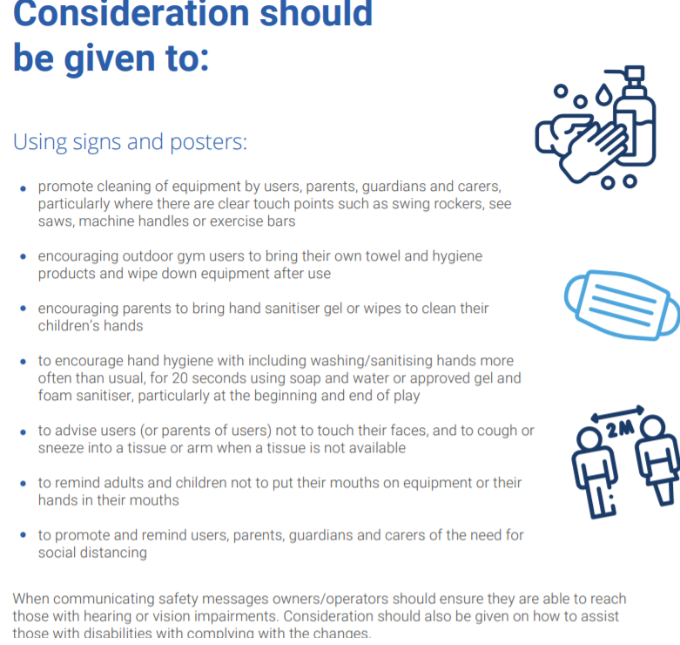
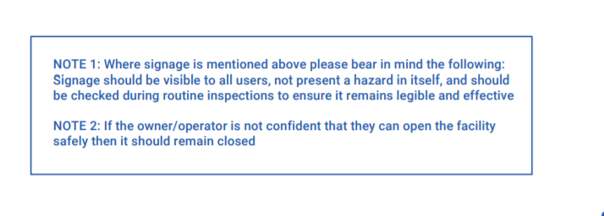
Council should also consider a vote which allows the Clerk to order the appropriate signage and purchase the relevant materials such as tape and rope to facilitate the CVPA opening should it be approved.
Item 13. Proposal of virement of £2500 from Badbury Railings fund to Badbury SIDs* and A346 crossing improvement funds.
The council has £2500 in allocated reserves to improve the footpath at Badbury by adding railings. The EGPA committee in June 2020 voted to not carry out these improvements and instead request the allocated funds be re-allocated towards to 2 x SID’s for Badbury plus A346 crossing improvements.
*Speed Indicator Device.
Item 14. Proposal of virement of £3000 from VE funds 2020/21 to VE funds 2021/22.
Due to the VE Day 2020 event being cancelled, a proposal is made to reserve these funds for use in 2021/22 for the planned VE day event in May 2021.
Item 15 and 16 see confidential papers attached to this email
Item 18. Expenditure of £75 plus VAT to Sansum and Co for budget report.
Financial Regulations state that the council will review the budget vs spend report every quarter to ensure the council funds are being spent in line with the budget. This report needs the budget figures inputting in our Xero accounting package annually. This charge is for the accountants Sansum and Co to ensure this is entered correctly to provide accurate information.

Item 19. Committee reports. June Finance reports. See spreadsheets attached to this email.

