Chiseldon Parish Council

The Old Chapel, Butts Road, Chiseldon, Wilts SN4 0NW
 01793 740744
email: clerk@chiseldon-pc.gov.uk
Facebook – Chiseldon Parish Council Notices
website: www.chiseldon-pc.gov.uk



18th May 2020 EGPA meeting, additional information.

Item 8. Badbury Railings Virement.

A further virement of £2500 would be required from 2020/21 general funds to allow the construction of new railings for the path between Badbury and Badbury Bottom. To be passed to Full Council for approval.

Item 10 – Further flood protection at Rec Hall for tennis courts.

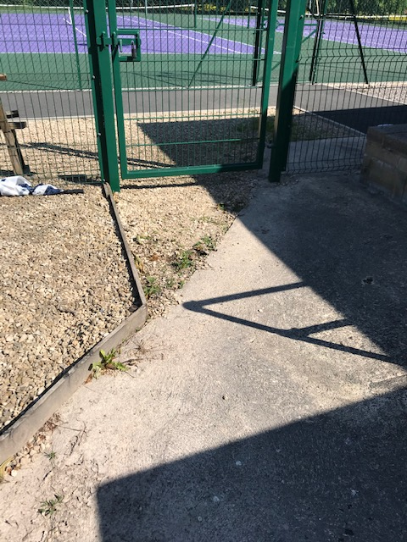

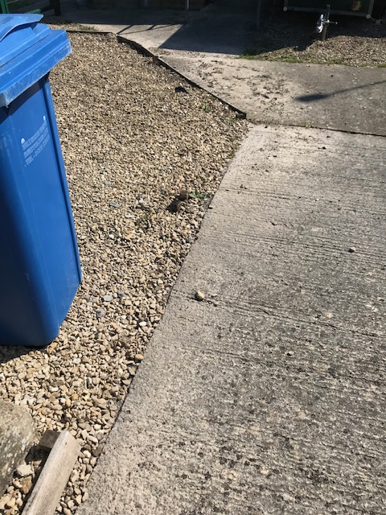

Julie Porte club Chairman will advice the committee on the views of the club.

Cllr Rawlings met with Paul Walton and Hardwick Homes who was the contractor for the work to discuss further steps. Cllr Rawlings to report back.

Discuss & vote on possible options to take.

Quote from Paul Walton for materials and labour from Matt Frost of Hardwick Homes attached: From August 2018. Voted on in Nov 2018 – committee consisted of :

Cllrs Matt Clarke (VC), Jenny Jefferies, David Hill, Paul Sunners, Keith Bates, Michelle Harris, Clair Wilkinson as Clerk.

Apologies: Cllrs Brady, Walton, McDonald and Rawlings

Drawings attached to this email.

Dear Clair

I hope you can read and understand my workings !!

I have measured the carpark areas and have made an assessment of the extent of the work that will be required to create the above .I have involved Matt Frost who as you might know lives in the Parish and is very competent at carrying out this type of work .He has given me his labour costs that seem quite reasonable .
The heavy plant and materials will be supplied by Tithegrove at cost and we will get the benefits of their buying power .

The total estimated cost for the works I have described will be £9089.00. I think though that with my advised specification subject to ground conditions this sum is quite completive and it may be prudent to put 10 % on top for budgetary purposes.

My only reservation are the ground conditions i.e. how much topsoil there is and how far we will excavate to get to good bearing ground .I would like therefore next Thursday get my gardener to dig some small trial pits to check the ground conditions to finally confirm.

If you have any queries or require further explanation please let me know

Best Wishes

Paul

A further quote from RedKite was obtained by Cllr Rawlings but was not chosen by the committee.

