Chiseldon Parish Council

The Old Chapel, Butts Road, Chiseldon, Wilts SN4 0NW
 01793 740744
email: clerk@chiseldon-pc.gov.uk
website: www.chiseldon-pc.gov.uk



11th May 2020 full council meeting, additional information

Item 1. Co-option of Cllrs *

For info only

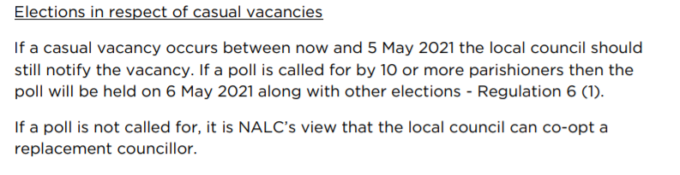

Item 9. Annual meeting of the Parish Council. *

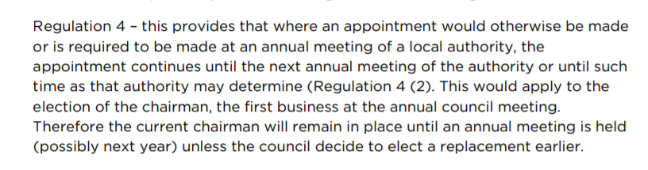

The law allows the current Chairman/Vice Chairman to remain in place until May 2020, unless either/both resign from their post, or the council vote to elect a replacement earlier via remote meeting.

Item 11. Annual Parish meeting. (The equivilant of our AGM) *

There is no Annual Parish meeting this year. (The law has been changed to allow this for 2020) A page will be created on the website and annual reports from all relevant parties displayed.

From NALC: Under Regulation 3 in the briefing it mentions that “Parish meetings are not included within the definition and, as such there is nothing permitting them to meet remotely. In NALC’s view, the current Government guidance means that parish meetings should not take place in person, including the annual meeting of electors.”

*. All legislation from the following act: 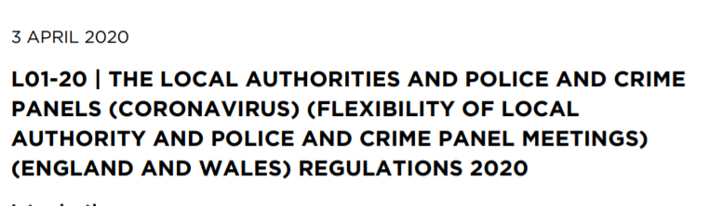

Item 14. History club grant request. (Our grants policy is attached to this email)

Chiseldon Parish Council Grant Application

Date 7 April 2020

Name of Organisation

Chiseldon Local History Group

Purpose of Organisation

- To research and record the history of the parish and make public the findings.
- To foster a lively community which is aware of its past and concerned for its future.

Date Established

1985 approx.

Contact Person Details

Keith Parsons,

Elected Officers

Chair; Elaine Jones,
Secretary; Keith Parsons
Treasurer; Alan Morton

Amount and Purpose of Grant Applied For

Estimated cost of project: £1400, including installation

Matched funding of up to 50% of the total cost, up to a maximum of £700.000.

To design, purchase and install a local history interpretation board in Church Street, adjacent to the entrance to Holy Cross Church.

Estimates as follows

Framework (Shelley Signs) £1,266
Design Artwork £ 80
Installation £ 50

Beneficiaries, and how the grant will contribute to the local community

All villagers who pass the site, including those who attend services and regular events at Holy Cross Church, will be able to see the board and to learn about the local history of the area.
The site is in the oldest part of the village, which has a rich history that may not be immediately evident to passers-by.

We believe an interpretation board will:

- enhance people’ enjoyment of our village, and their appreciation of our history, of which few traces remain.

- further our aim to share information about our heritage to as wide an audience as possible.

- promote the museum and the work of Chiseldon Local History Group

Other Grant Applications Made

The Chiseldon Memorial Hall Trust

Contribution from own funds

A copy of our financial statement for 2018/19 (Attached to this email) and the quotation from Shelley Signs are enclosed.

Keith Parsons
Secretary
Chiseldon Local History Group

