Chiseldon Parish Council

The Old Chapel, Butts Road, Chiseldon, Wilts SN4 0NW
 01793 740744
email: clerk@chiseldon-pc.gov.uk
website: www.chiseldon-pc.gov.uk

18th November 2019 EGPA meeting , additional information

Item 6 – New dog bin in Badbury

Costs are:
Cost of plastic dog bin £103.82 inc VAT, and £50 plus VAT installation. Collection £2.50 per week, £130 a year plus VAT.

Possible location is at the start of the footpath from the main Badbury Road leading to Badbury Bottom. Other suggestions welcome. Remember that these bins can smell in the summer.

Item 8. Leaf blower purchase.

Information to follow, purchase information from Stahl.

Item 16. Sign for Rec Hall exterior

1.5 x 1m sign in aluminium, £73.30 plus VAT (total £87.96).

Item 17 - New play items for CVPA.

For Younger children
Supply only items from Wicksteed: (some options are)

CODE | DESCRIPTION | UNIT PRICE | QTY | TOTAL
6400-080 | Flying Bats Cog Spinner | £ 697.00 | 1 | £ 697.00
6400-081 | Sands of Time Rotating Play Panel | £ 697.00 | 1 | £ 697.00
6070-054 | Talking Flowers | £ 495.00 | 1 | £ 495.00
6070-175 | Talking Pirates | £ 495.00 | 1 | £ 495.00
 |  | Subtotal |  | £2,384.00
 |  | Carriage |  | £ 119.20
 |  | Total excl VAT |  | £ 2,503.20

Please note this is not an official quotation.
All prices exclude VAT.
Errors and omissions excluded.
Wicksteed terms of sale apply.

Total budget for 2019/20 is £3500 for new equipment
None of this budget has been spent.
See saw and bench were from 2018/19 budget.

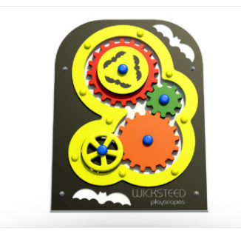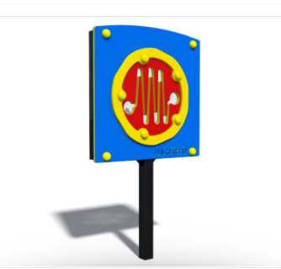

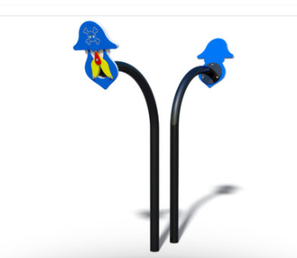

Recommendation: Flying bats, sands of time and pirate talking tubes – total cost approx £2000 plus handyman installation costs.

For older children who can play outside of the fenced area:

Sovereign Play have a large section of individual pieces that can be bought over time to create a trail.

For example:
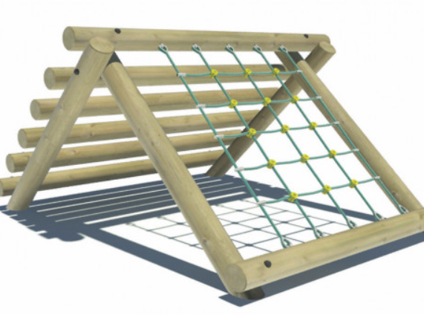
£1490 ex VAT. (£298 VAT) inc delivery and installation 1.5 meters high

Or this scramble net from Playdale Playgrounds for £1827. Ex VAT plus £229 delivery.

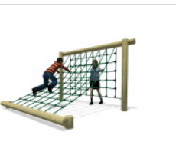

Or
Scramble Climber £992 ex VAT plus £124 delivery. 1.4 meters high

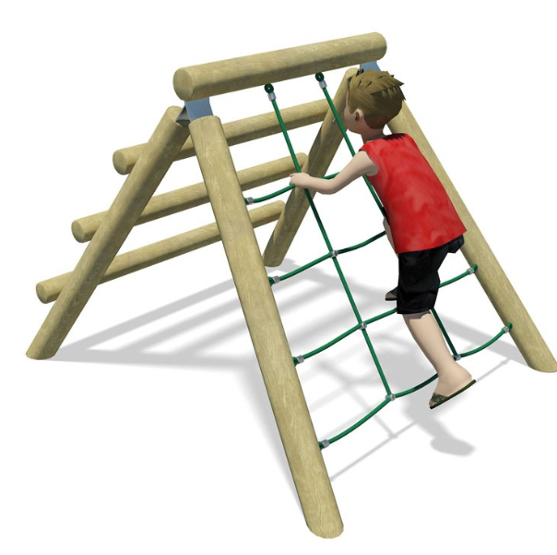

Or Spider Web £1097,, ex VAT, plus £138 delivery. 1.5 meter high poles. Net 0.55 meters high.

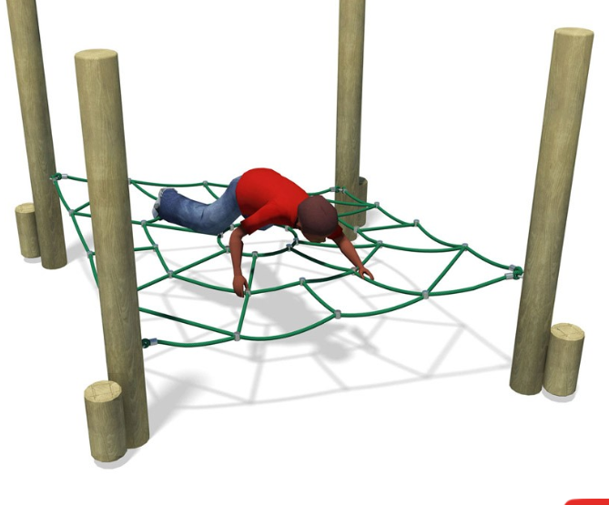

Can use along with boulders to form a natural trail:

Stone Warehouse:
Eg. Gritstone boulder measuring 120cm x 90 cm x 44 cm @580kg. £312.20 including VAT and delivery. Would need a friendly tractor driving to push it into position as delivery is to road side from lorry only.

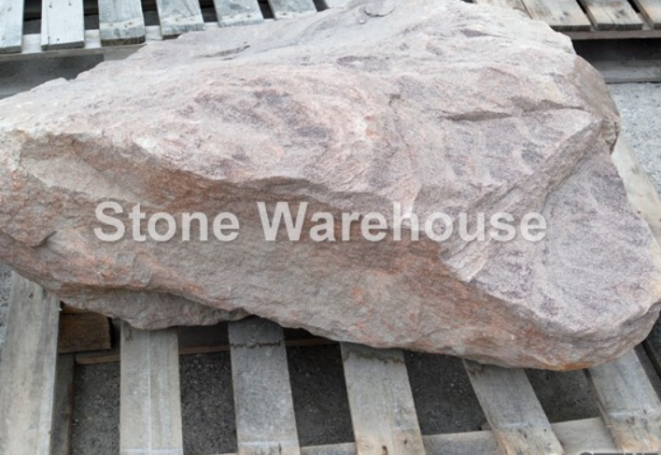
Or

88cm x 650cm x 490cm £245.20 inc VAT and delivery (as above)

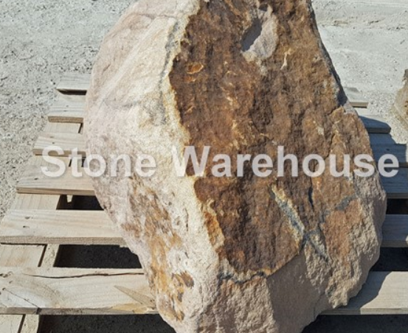

Recommendation:
Sovereign Play cargo net as includes delivery and installation in costs.
Include further equipment and boulders in 2020/21 budget.

Or

Playdale Spider net with boulders for additional play – up to remaining budget of £1500

Will need to ask permission from SBC to place items on the green at Castle View Road.

Item 18 – Chapel doors refurbishment

Hatch Heritage quote:
See document attached to this email

SN4 Carpentry quote:
See document attached to this email

Further work would then be carried out to sand and re-paint the doors.

Item 20 – Gate sign for Chapel
The Chapel offices are still not known to many. A quote has been obtained for a sign to match the museum sign, to fit to the stone pillar of the gates.
Quote is £27.18 plus VAT (£32.62)

