Chiseldon Parish Council

The Old Chapel, Butts Road, Chiseldon, Wilts SN4 0NW
 01793 740744
email: clerk@chiseldon-pc.gov.uk
website: www.chiseldon-pc.gov.uk



14th October 2019 full council meeting, additional information

Item 7 election cycle consultation

Proposal from SBC to change the election cycle from thirds with 1 fallow year to all elections once every 4 years.
If CPC agreed to change their parish election cycle to match that of SBC changing to a 1 in 4 year cycle then our costs would be minimal as we’d use the facilities that SBC would be already using – polling stations and polling clerks etc. Our costs would be the same as they currently are. (depending on whether it was contested or not)

If however the PC wanted to keep their current election cycle which would be different to the new proposed SBC cycle, then the costs we could expect approximately are
Electorate 1965, 2 polling stations
£4,800 polling station costs with polling Clerks and officials
£480 cost count
£5270 costs per election
Would need to budget £1318 per year to account for this.

Our next election year currently would be 2023. Changing to the SBC model would move it to 2022 and then every 4 years after that.

Item 8 Asset of Community Value for Smokehouse.

A suggestion was raised to submit an ACV form to SBC for the Smokehouse pub.
An ACV is a way to register an asset to a community so that if the building/land is proposed for sale, the owners have to give local communities the chance to create a plan to purchase and run as a community business. There is no cost to registering this, and the Parish Council have no further responsibility or obligation. If local communities have no interest or cannot raise funds, then the sale of the property/land continues as normal.
An ACV has been submitted for the Calley Arms in Hodson.
Read more here: https://www.swindon.gov.uk/info/20029/people_and_communities/513/community_right_to_bid

Item 15. Hightways work required via SBC
Extract of letter from Steve Jorden at SBC:
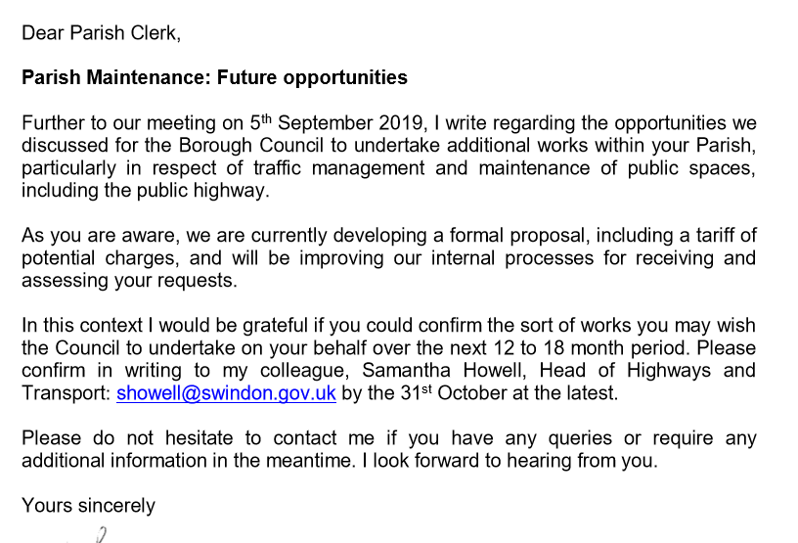

SBC are proposing a staff member to liaise with PC’s and arrange works at the PC’s costs using SBC resources/skills. This letter is to determined if there is enough work to employ such a person.
We could include items such as:
Parking solution for Castle View Road near the school on the green area.
Any dropped kerbs that may be required
Extra parking provision for Windmill Piece.
Improved parking provision at Draycot Foliat
Verge parking issue at Ridgeway View
New Road build out.

Item 16. Amendments to Financial Regulations
See document attached to this email

Item 17. August and September financial transaction documents.
See documents attached to this email
October to date provided for information only.

Item 18. Budget considerations for 2020/21

To consider items for the budget/precept.
Could include:

EGPA –
budget for Ash die back issue
Wildflower areas – Suggest 1 site as a test plot maybe? Could do an area of strouds hill as there is no traffic field of view issues here.
New CVPA equipment for older children
MUGA at Rec Field
Xmas tree
Path rail at Badbury
Any ideas for Hodson, Ridgeway View or Draycot Foliat improvements
Youth club provision at rec hall

Finance –
Clerk assistant
Laptop for assistant
Training budget for clerk and Cllrs
VE day budget
Funds for professional parish flyers/leaflets as needed
Community bus share with Haydon Wick – I have some info on this I can share

Planning -
Roll over funds for consultant from 2019/20 budget and ring fence them in 2020/21 budget
Solar powered lighting for Strouds Hill carpark
Next area to have parking created

Funds into Rec Hall replacement
Funds for next parking improvement

Councillors to bring their suggestions to the meeting.

Item 19. Rec ground drainage additional quotes

Quote from Sam Hughes, Red Kite Building:

Blind car park with 20 tonnes of aggregate dust and compact.
Remove existing cap drain and replace with 6 meters of 150mm drain.
This to be connected to existing.
Install plastic land drain at 10 meters long.

Total price
£2800

Original quote for extra work was:
The prices are as follows;
4 days hire 3 tonne mini digger £157.50
.. .. … 4 tonne dumper £075.00
.. .. .. 1200 roller £093.60
Delivery/collection £030.00 £ 386.43

Labour 4x8x£24.00 £768.00
4x8x£18.50 £592.00 £1360.00

Materials

I tonne shingle £036.00
I tonne ballast £036.00
Cement 3x£3.00 £009.00
Aggregate Dust 20x£20.00 £400.00
Aco drain 6x£51.33 £307.98 £788.98

Total £2535.41

