Chiseldon Parish Council

The Old Chapel, Butts Road, Chiseldon, Wilts SN4 0NW
 01793 740744
email: clerk@chiseldon-pc.gov.uk
website: www.chiseldon-pc.gov.uk



24th September 2019 interim full council meeting, additional information

Item 8. Additional costs from SBC for Norris Close layby.

See additional attachments to this email.

Item 9. Reply to SBE on SHELAA site SO432
Residents have requested that CPC send in their response to this site on the SHELAA.

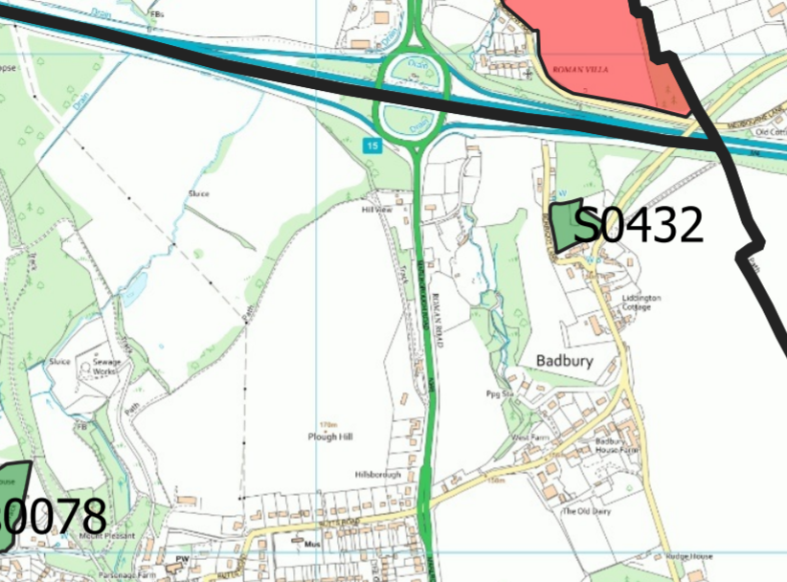

Resident’s comments:

You will have already received a letter in response to the request for comments on the present draft local plan from our planning consultant, Graham Warren, but I wanted to add my personal voice to his. In addition, you received a letter from Mr Warren dated 11th April 2019 in respect of the SO432 and the SHELAA 2019 and all of his comments in that, of course still stand.

In his recent letter, Mr Warren has in particular commented on question 1 of the consultation and has suggested the introduction of an additional paragraph on the subject of development in small villages and hamlets and I do, of course endorse that suggestion.

The consultation questions (at number 3) also ask for comments on the specific housing sites under consideration and Mr Warren has so commented on SO432 in his letter of 11th April. I should like to make a few more personal comments on the unsuitability of SO432.
- In the last week, Royal Mail has removed the post box which was in the wall outside The Manor; so that is yet another facility lost to our little hamlet which makes the development even more unsustainable.
- Again in the context of sustainability, the cramped layout and small gardens of the proposed site, in comparison to the rest of the hamlet, means that the growing of food will be nigh on impossible and we have no allotments to alleviate the issue.
- The high volumes of traffic through the hamlet, the narrowness of the lanes and the number of cars parking for the nearby pub all make it very dangerous to risk overspill parking from SO432. The cramped nature of the planned estate, however makes such overspill almost inevitable.
- At the present time, the site is being used for agriculture and there are sheep happily grazing there. The development of SO432 will represent a loss of productive agricultural land.
- SO432's proximity to motorway noise and pollution will be deleterious to the health of the residents of the new housing estate.
- Further traffic through the hamlet will add to the dangers of an already overused and narrow lane. That it is dangerous is clearly evidenced by the fact that we ourselves lost a well loved pet to the road some months ago.
- The impending closure of Honda will significantly reduce the need for additional housing in the area and the assumptions inherent the draft plan were produced before Honda's announcement. The need for this unpopular and marginal site should now, therefore be reviewed.
In summary, I believe that the development of SO432 is ill-conceived, heavily opposed, not deliverable and should be withdrawn from the Local plan. This view is clearly shared by the vast majority of the local residents, as evidenced by the yellow "NO to SO432 Housing Estate" posters displayed in all but a few houses in Badbury. Whilst additional low cost housing in Badbury is desirable, the only development to be permitted in the hamlet should be infill along the current lanes, so as to maintain the linear nature of the settlement and its historic setting within the landscape.

Dear sir / madam,
We have previously written to you twice tracking our concern regarding the site allocation proposals for site ID S0432 in Badbury. These were dated 18th February and ……….. We asked for these letters to remain on file and to be used as feedback at the next stage of public consultation which is now open. As we have not received any formal SBC acknowledgement, we write again to ensure our thoughts and objection to development are considered.
We have since benefitted from attending the two meetings at Liddington Village Hall organised by Councillor Gary Sumner who invited the potential developer along to present his emerging ideas. Whilst there were over 30 attendees who appeared to be against the proposals it is clear that the POTENTIAL developer (Peter Mapson) has attempted to listen to my earlier design feedback (I am a Chartered Architect). The issue at hand is that the suitability of the site for development is not considered appropriate when viewed in context against the various current Planning Policies at this particular location. There is also the fact that none of us can guarantee that the scheme presented is the one that would be taken forward and build in the course of time should the site be recognised in the SHELAA process.
Whilst we have contributed positively to the informal consultation process (I append the two earlier letters to demonstrate this) and can acknowledge the proposals evolving we still feel the need to object on the basis of:
1. We live in the small community of Badbury directly opposite the site. Your local Plan review should not dilute the existing national policies relating to AONB and associated Village Conservation Areas with associated Listed Buildings / Significant Interest that immediately surround the site. The landowner has evidently not maintained or harvested the field since these proposals have been tabled. It is a shame to see what appears to be deliberate waste / neglect albeit the established wildlife is loving it!
2. We are told that specialist SBC planning officers have now visited the site (?). The site merits visit and review of the setting with defined Heritage Assets and Green Infrastructure within the AONB. The NPPF does not appear to support such developments. It is abundantly clear that the site is relatively constrained, outside the settlement boundary, in the North Wessex Downs AONB, immediately adjacent to the Badbury Conservation Area and where development would directly impact on the setting of neighbouring Listed Buildings. The recent July 2018 National Planning Policy Framework states at para 172 that great weight should be given to conserving AONBs. Ultimately, Planning Permission should be refused for major development. The footnote to the paragraph states that “major development” is a matter for the decision maker, taking into account its scale and setting and whether it could have a significant adverse impact on the purposes for which the area has been designated. Similar considerations apply to Conservation Areas and Listed Buildings.
3. In the context of the ‘hamlet village’ of Badbury this development site is considered major, increasing the number of dwellings in the village by almost 40%? The simple question to be asked is does the village need this amount of development especially when close to major development areas?
The site is outside of the defined settlement boundaries. The character of the Conservation Area would undoubtedly suffer with a development anywhere near the size of 20 units (now reduced to 18 larger units?) mentioned in SHELAA (and the potential developers sketches). Coalescence is not appropriate and would set a dangerous precedent effectively linking developments across the M4 at J15.
5. The site falls within the North Wessex Downs AONB which should be protected. The National Trust document ‘AONBs and Development 2015’ provides support in protecting this kind of site. Chiseldon Parish consultation on the other AONB sites has already established firm guidance on development proposals (see parish minutes).
6. The Site is directly flanked by 3 Listed Properties and others that are noted as Significant Interest. It is their setting and ‘group values’ that are valuable in addition to the physical properties. The linear nature of the village within the unique Ridgeway escarpment is worthy of continued protection. The Village Conservation Area Report clearly records that the Village boundary was deliberately kept tight to reinforce the Village value within the surrounding AONB. Extending the settlement boundary would never have been anticipated as appropriate and we trust that future versions of any Neighbourhood plan would support this. This will be the key test and one I will fight to protect. The council may try and sight a ‘special circumstances’ clause from paragraph 172 of the NPPF due to the apparent shortage of housing supply land but local residents would highlight the new empty houses to be found in the adjacent area. It is also widely publicised that the methodology for calculating ‘need’ is under scrutiny. The Ministry of Housing Communities and Local Government 2014 based version vs the Office of National Statistics 2016 household predictions which often results in lower figures.
7. The site plan is small scale but would appear to include / abut a public right of way. Clarity on the guidance provided in the Countryside and Rights of Way Act 2000 should be considered. The potential developer seems to have started to address this issue since we raised it but could go much further by creating enhanced permeability into the site from all sides to avoid creating a ‘silo’ / housing estate in Badbury which is a linear village.
8. The site is compromised by existing services (HV overhead cables that cross the ridge on site at relative low level, Thames Water Main Pipeline flanks the site and will need ongoing access covenants). Any developer would need to factor in these costs in their viability. Badbury Village infrastructure will need assessing and potentially upgrading if additional housing is built. We have existing Sewer Capacity issues as an example. The 20-house number mentioned in SHELAA is a very high number for the site based on simple masterplan viability that I have the capacity to undertake as an Architect. I would respectfully suggest that the density of any forthcoming proposals would struggle to respect the existing village densities and context whilst maintaining viability.
10. I question the detrimental impact on the already struggling local public services in terms of meeting public demand. This is particularly difficult in the peripheral villages where other expansion sites have inundated the existing services. Sewer capacity in heavy rain is already an issue and Broadband suffers. What contributions could be guaranteed if significant development is deemed as required?
11. Access into the site will need to be considered carefully. Berricott Lane is very narrow and the Badbury Lane / Medbourne Road suffers with high volumes of fast traffic at peak periods. Safety concerns and the potential introduction of a new junction would be detrimental to the arrival within the picturesque Northern end of the village. Reliance of Traffic Engineers ‘capacity figures / sight lines’ alone will be misleading unless the real-time Badbury Rat running and speeds are recorded. Full traffic calming and extension of the 30 mph zone should be delivered with any further development in the village. Paragraph 109 of the NPPF suggests that ‘….development should be prevented / refused on highways grounds if there would be an unacceptable impact on highway safety, or residual cumulative impacts on the road network would be severe….’. The lane through the village of Badbury is single car width at various places and the peak flow is already a concern that the Parish Council is aware with high speed ‘Rat-running’ to avoid the J15 tail backs up Plough Hill (A346).
12. The site currently enjoys much wildlife and effectively provides a ‘wildlife corridor’ around the northern edge of the village being flanked to the north by the M4. We see deer on a weekly basis in addition to smaller wildlife (i.e. Badger trails into the site) and birds of prey actively hunting in the grassland.
13. Noise & pollution from the adjacent M4 may be a concern. The developer mentions an acoustic barrier. Will this be attractive, maintained and benefit all? Better to screen the Motorway slip road at source.
14. Whilst there is no right to ‘views’ we feel that the Character of the village will be adversely affected from within and from outside. There is some site screening but not enough to reduce impacts sufficiently.
. We welcome the potential developers sketch design which has been revised to include street facing properties to Medbourne Road which starts to recognise the linear pattern of the village. The thatch properties are much better and traditional vernacular promised is appropriate. These promises can never be guaranteed in the planning permission process (i.e. it could be sold on or alternative applications made at later dates to dilute the scheme). Density and cramming in units to the back of the site is what makes it feel like an ‘estate’. Any development should be well linked in with the existing with the Masterplan and Design Statement underlining how this is successfully achieved. This has not been presented satisfactorily to date.

We have copied this letter to the Parish Clerk for sharing to ensure it is debated within the locality with appropriate representations being made. Please acknowledge this letter by confirming that it will be held on file in objection of this site being identified for potential development in SHELAA for Swindon.

Item 11. Monthly account transaction reports for May, June and July.

See additional attachments to this email

Item 12. Budget report

See report attached to this email

Council to review this report to understand the figures shown and discuss how to use it to monitor spend vs budget across the financial year.

Item 13 VE Day celebration 2020 – 75th anniversary. Parish event on Rec ground.

A proposed £2000 budget approved to secure the hiring of items such as marquee, portaloo’s, St John’s Ambulance and stage etc.
Further funds may be needed in 2020/21 budget?
If we apply in the next few weeks, we can ask for a free flypast.

Joanna Edwards, event planner has been offering some free advice. I have asked her for her fee’s to assist with arranging this event.

 |  |  |  |  |  |  |  |  |  | Task Order Reference Number: | HCW.1819.016
 |  |  |  |  |  |  |  |  |  | Date Received:

