# *Chiseldon Parish Council*

The Old Chapel, Butts Road, Chiseldon, Wilts SN4 0NW

 01793 740744

email: clerk@chiseldon-pc.gov.uk

website: [www.chiseldon-pc.gov.uk](http://www.chiseldon-pc.gov.uk)



**16th Sept 2019 EGPA meeting , additional information**

**Item 6**

Cost of plastic dog bin £103.82 inc VAT, and £50 plus VAT installation. Collection £2.50 per week, £130 a year plus VAT.

Proposed location X attached to existing railings.

There is a further dog bin at the start of the track next to the field, at the entrance to the Washpool from Church Street and at the start of Home Close from Hodson Road.

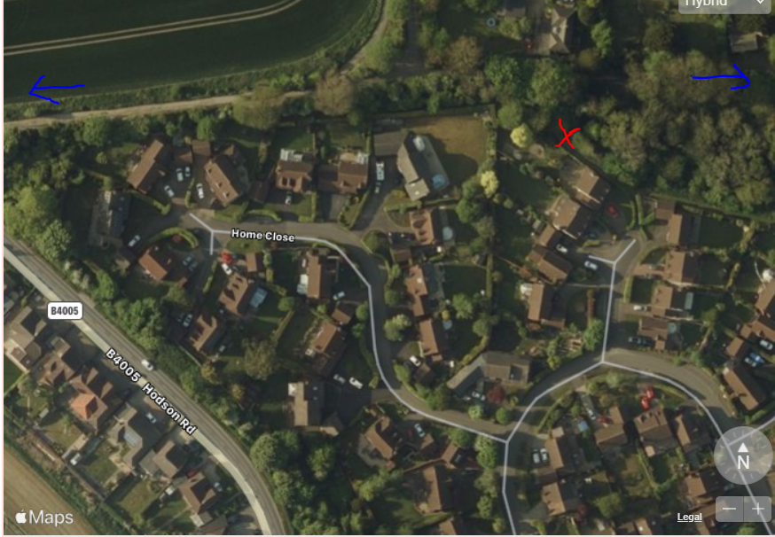

**Item 7**

Approximate costs from Allbuild to reduce the width of New Road hedge (Not on path side as posts and old fencing are a hazard) £1500.00 plus VAT for a weeks work, plus removal of waste.

The parishing map for side arm work is attached to this email (from 2017) and the New Road hedge is not included. Ward Cllr Jefferies has been made aware of SBC’s obligation to this hedge.

CPC costs have been kept low by requesting the probation team cut back this hedge.

**Item 8.**

**Informal consultation to all Badbury residents ref noticeboard location.**

**Replies received were:**

NB  I refer to "The Hollies" and "Holly Trees" in this email,  They are two separate properties.

Thank you for your letter, which was delivered by Ms Rogers. asking for comments on the Badbury notice board.

I live in Berricot Lane and we cannot see the board from our property.  For five houses it is in their direct view of the hamlet.

We were driving out of Badbury on the morning that the notice board was erected, a couple of our neighbours were there and I get the impression that they were opposing the installation.  I know that the occupant of The Hollies is also strongly opposed to its present siting.  I feel that it is an eyesore where it is and I have never seen anyone looking at the notices on it.

OPTIONS:

Siting it at the far end of the hamlet does not seem very sensible but there is only one other possible place:  in or near the red 'phone box by  "Holly Trees".  The design  and size of the board would have to be adapted and I am not sure what the owners of "Holly Trees" would feel about this positioning!

I do not think the notice board should stay in its current position as:  it is an eyesore; it is disliked by the adjacent properties; as far as I can tell, the notices are not looked at.

It is likely that Badbury residents would not worry if there was no notice board, as it appears that the notices are not read and the notice board at Oakleys is not far away and is very accessible.

NB.  It could be of benefit if Badbury had a defibrillator machine in the old phone box.

Unfortunately the notice board does seem to be in the only viable site, which isn’t ideal as it is not on a usual walking route through the village. I do wonder if it would be better turned around. For anybody not receiving the parish magazine or following the parish council website it would be the only way of finding out what might happening locally.

Thank you for your letter regarding the location of the Parish notice board in Badbury and allowing informal consultation of the location/need for the notice board.

We have long maintained that the notice board was put in the wrong place. It is currently placed on the green/Berricot Lane which is a single track road to an dead end/no thoroughfare. This is too far away from the hub of the village to see and as a result I rarely see anyone look at it. We live in area of conservation and of natural beauty and its current location degrades the surroundings in which we live. It is also a safety issue in that motorists are blinded as they approach the T junction as they cannot see traffic approaching from Liddington direction. In addition, the board has not been maintained since it was installed and now the cheap Perspex cover has discoloured due the UV sunlight making the notices unreadable.  This really defeats the purpose.

We, personally, do not look at it or need it as we get a lot of the information from the Parish home page on Facebook. However I understand not everyone has access to the internet/Facebook and therefore an alternative location is needed. However, if information is needed urgently we have been notified individually by hand delivered letters/posters therefore I question if a notice board is needed.

The original location was on the main lane through the village and while I understand the safety issue regarding this location – it was positioned next to the post box and centrally located for all to look at. I would prefer the board to be returned to its original location or more central to the village and the main hub of the village - the pub.  It could easily be placed near the car park entrance or near the entrance to the pub itself.

An alternative would be to consider the telephone box.  I understand through Parish meeting minutes that the telephone box will be staying - it is a landmark to our village and it would make a great focal point for village affairs.  There are many alternative uses for the using the telephone box including a library, history of the village and housing a defibrillator/first aid.  I would like the Parish to consider this as an alternative.  I would have suggested this to begin with if consultation had been permitted.

I have included a link to article regarding other uses for the telephone box.

<https://www.wired.co.uk/article/bt-scrapping-phone-boxes-alternative-use>

I hope this helps in the consultation process,

Although the residents down our lane don't appear to have had notices about the consultation put through our doors, I have seen them at other properties throughout the hamlet.

To be honest, I don't really know what the problems are with the notice board being in it's current place, although I'm not sure just how many people stop & look at it. I am probably among the minority that DO as I pass by it on a weekly basis.

As has been noted, during the last consultation several years ago, other sites were put forward, but were rejected by SBC as not being safe. It would be a shame to lose it completely as Badbury needs to try to stay 'in touch' with the Parish Council &, other than being online & having the Ridgeway Bell, this is one of the few other ways of getting information out there.

Thank you for the correspondence posted through my letter box the other day regarding the location of the Parish Noticeboard.

I wish to propose the new site by the old telephone box, it then is central to the village.

I do hope that the Noticeboard stays and does not get removed, if that was the case I wish it to remain where it is.

Dear Council,

We have been residents here for 33 years. We enjoy living here and are keen to make improvements where we can.

Thank you for the communication re the positioning of a notice board for Badbury. Communications , always quite difficult, do need to be assisted here.

Wherever you place a notice board in the village is unlikely to be used properly. Just about none of the villagers walk in the village, we don’t think. The most we ever see is the odd person coming from the bus stop, mostly to work in the care home, or occasionally a few leaving The Old Dairy commercial zone to go to the pub. With no pavements, increasing traffic, and the difficulty in stopping a car along the road, you are right in saying it is not safe, or in fact pleasant, to do so. A sad situation !

Wouldn’t it be better to move with the times a little, and set up an e mail network so that just about everyone could be informed of local information etc quickly and effectively by that means ? I’m sure that an e mail address request from you could achieve this without a lot of fuss from a large percentage of the village. It is the method chosen by some of the local clubs, eg the Gardening Club, for effective communications, and it works very well.

If it is still deemed desirable to continue with a noticeboard as well, then by the telephone box or outside the pub somewhere on public ground would be two possibilities.

Thank you for the consultation regarding the Badbury PC notice board.

Previously siting was also considered near the phone box and outside Stocks Close.

Siting near the phone box could be reconsidered.

As a matter of interest I have never used the noticeboard. My husband has.

The PC website provides all the information and more. Is the noticeboard necessary?

We would not miss it if it was removed.  We would use the website.

*Plus 2 letters scanned and included on the email.*

**Ridgeway View noticeboard:**

A new board was ordered for Ridgeway View, but a resident in the meantime removed the old one, refurbished it and concreted it back in place at the original site.

This leaves us with a smaller sized green metal board. An option could be to remove the original Badbury board, and use the smaller green board to go behind the red BT box in Badbury, if a defibrillator is purchased for this site then it would become a new information/community hub?

**Item 9**

Residents have expressed concern over a “blanket” ban on being able to drive onto the grass for short periods of time, and for tradesmen to park for work on properties.

The committee to consider:

1. Risk to residents from vehicles driving on the green
2. Benefits to residents from vehicles temporarily being allowed to access the green by vehicle.
3. The council can only make a recommendation, and if necessary follow up with physcial barriers and reports to the police and SBC.
4. Use of a planter to try to prevent driving on the green, or re-site planter as a feature of the green only. (Planter has been ordered as per previous committee vote of approval)

**A vote is to be held as to where to place the planter and whether to follow up with un-necessary driving across the grass area.**

**Item 12**

A resident near the allotments has complained several times about bonfire smoke drifting into his property from the allotments. The lease permits bonfires that do not cause a nuisance however the Allotments Act 1950 doesn’t specify what a nuisance is.

**I have received this advice:**

Technically there is no law against. However, if it is a repeated 'substantial' nuisance, district council's environmental health dept. can become involved. Usually the complainer is required to keep a diary/log of incidents and submit to EH. [https://eforms.aylesburyvaledc.gov.uk/ShowForm.asp...](https://eforms.aylesburyvaledc.gov.uk/ShowForm.asp?fm_fid=322&fbclid=IwAR30WMgy-hVimE4ubnXSTu8OxsLXGslt_VxhCkPWXgjCfdvAoWzhDLKZBZ0)

I asked the resident what they would like to see in place. They suggested a sign on the allotment gate asking that bonfires were not lit if the wind was blowing in “X” direction towards the properties on New Road.

Approximate cost for a sign from EW works would be £30-40.

Note. The properties have heat recovery ventilation units which draw in outside air to ventilate properties. A full 24 hours is needed for any smoke to be removed by this method.

**Item 15**

**Message from SBC with regards to a residents request for safer speeds at Norris Close:**

As a street lit 30mph road it is not permitted to erect speed limit reminder signs on Norris Close and I'm afraid I don't expect speeds and collision data would prioritse this road for the consideration of anything more substantial.   
The sign the resident refers to that they have seen at a campsite in Cornwall is, I expect, not on public highway. There would be nothing to say the Parish couldn't erect something similar at the Recreation Ground car park exit to remind drivers to be considerate to local residents. They could also ask those hiring/using the Rec Ground to remind their visitors/members to watch their speed on leaving.  
Elsewhere local residents have purchased stickers that are adhered to refuse bins that when positioned on the roadside remind passing drivers of the speed limit, perhaps this is something the residents or Parish could consider investing in.

**Quote from Enterprise Works for Stickers with CPC logo on:**

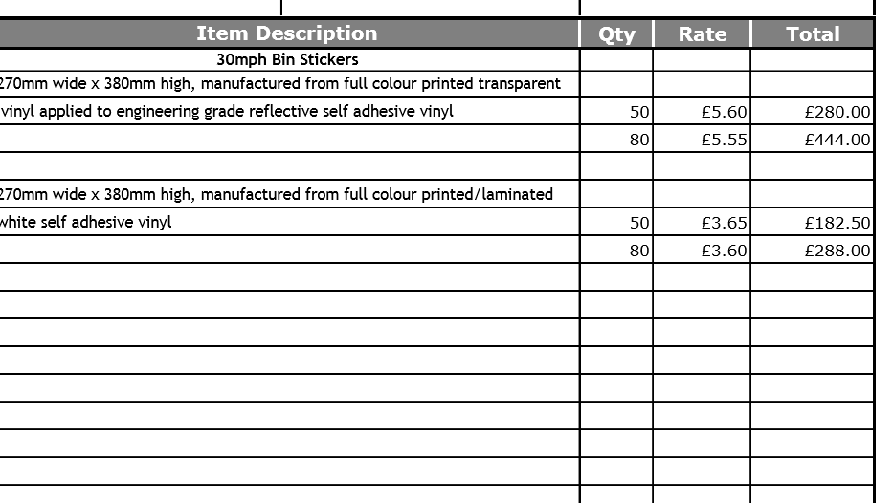

VAT TO BE ADDED.

Marlborough Bins:

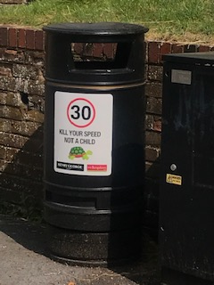

It would appear they have local businesses to sponsor these signs as they have their logo printed on the stickers. (No extra charge to do this from EW)

**Enterprise Works quote for sign for Norris Close track:**

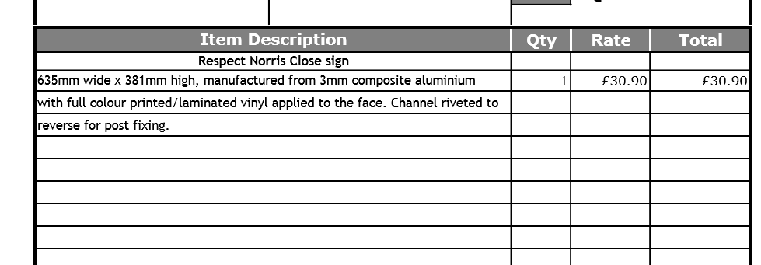

VAT TO BE ADDED

Text to read “Please respect this area when leaving and drive safely and slowly down Norris Close” or similar.