Chiseldon Parish Council

The Old Chapel, Butts Road, Chiseldon, Wilts SN4 0NW
 01793 740744
email: clerk@chiseldon-pc.gov.uk
website: www.chiseldon-pc.gov.uk



19th August 2019 EGPA meeting , additional information

Item 14

Message from SBC with regards to a residents request for safer speeds at Norris Close:
As a street lit 30mph road it is not permitted to erect speed limit reminder signs on Norris Close and I'm afraid I don't expect speeds and collision data would prioritse this road for the consideration of anything more substantial.
The sign the resident refers to that they have seen at a campsite in Cornwall is, I expect, not on public highway. There would be nothing to say the Parish couldn't erect something similar at the Recreation Ground car park exit to remind drivers to be considerate to local residents. They could also ask those hiring/using the Rec Ground to remind their visitors/members to watch their speed on leaving.
Elsewhere local residents have purchased stickers that are adhered to refuse bins that when positioned on the roadside remind passing drivers of the speed limit, perhaps this is something the residents or Parish could consider investing in.

Quote from Enterprise Works for Stickers with CPC logo on:

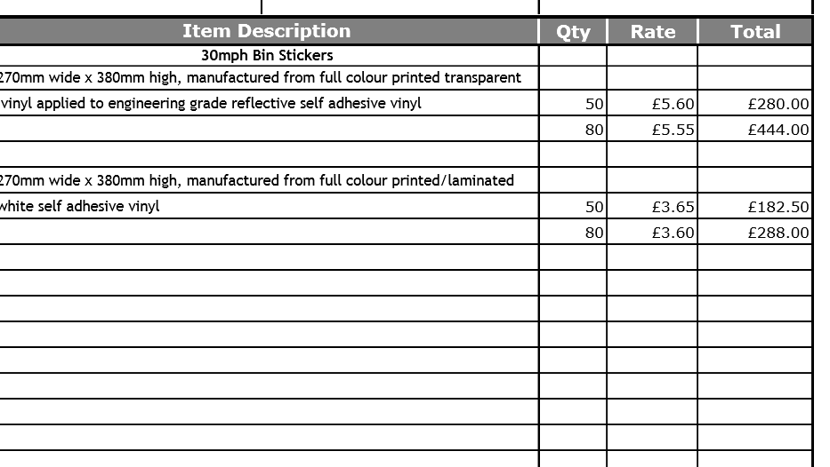

VAT TO BE ADDED.

Marlborough Bins:

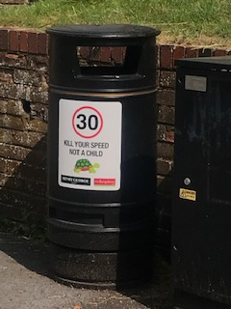

It would appear they have local businesses to sponsor these signs as they have their logo printed on the stickers. (No extra charge to do this from EW)

Enterprise Works quote for sign for Norris Close track:

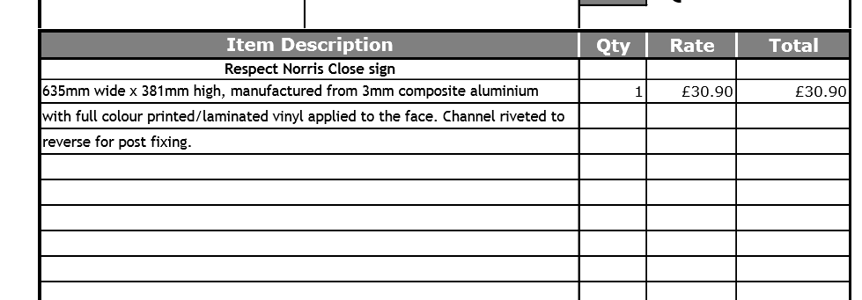

VAT TO BE ADDED

Text to read “Please respect this area when leaving and drive safely and slowly down Norris Close” or similar.

