

# *Chiseldon Parish Council*

**MINUTES of the ENVIRONMENT, GENERAL PURPOSE AND AMENITIES COMMITTEE meeting**

**held on Monday 15th July 2019 at 7.30pm in The Old Chapel, Butts Road, Chiseldon**

**Present:** Cllrs Chris Rawlings (Chair), Jenny Jefferies, Denise Rogers (VC), Paul Sunners, Keith Bates. Clair Wilkinson as Clerk.

**19/57. Declarations of interest & approval of any dispensations.**

Cllr Rawlings rents an allotment from CPC.

**Public recess.** None

No public but Matthew Clarke in attendance for the Football Club and Matt Griffith in attendance in reference to item 19/60

**Approval of Apologies:** None **Absence without apologies:** none

**19/58. Approval of previous EGPA minutes from 17th June 2019.**

No changes

**The minutes of the meeting held on 17th June 2019 were approved as an accurate representation, proposed by Cllr Bates, seconded by Cllr Rogers; all those at the meeting were in favour.**

**19/59 . Action points from June 19.**

***SUMMARY OF ACTION POINTS***

|  |  |  |
| --- | --- | --- |
|  |  |  |
|  |  |  |
| **Clerk** | *18/137*  *19/13*  *19/43*  *19/44*  *19/45*  *19/49*  *19/50* | Monitor properties at Turnball & Slipper Lane for overgrown foliage into road and write letters if needed. Still being monitored  Add item to July/Aug agenda ref rolling new carpark at Rec. Will be added to August.  Finance committee to approve final costs of petrol strimmer & safety equipment. DONE- added to agenda.  Write to Strouds Hill residents advising their original views on seating will still be noted. DONE  Finance committee to approve costs for Limeway to repair the Memorial Stone on New Road. Added to agenda. DONE  Finance committee to approve costs of £850 for the removal of Ash tree on Rec ground. DONE  Finance committee to approve costs of £125.00 for STORM to fix leak at Rec hall. Ongoing as quote may change. |

**19/60. PARISHING PROGRESS - Matt Griffith, Tree Surgeon talk on Ash Dieback**

* Ash Dieback is a fungus and trees can in some cases survive it
* 80/90% of ash trees may die in the next 5 years
* Lesions will form and the crown or entire tree will start to die
* It weakens timber so can be a hazard
* CPC should consider putting aside funds for future years to cover this
* Should consider a fund to re-plant – approx. £50 per tree for one a suitable height. Hornbeam or Acer suggested as good alternatives
* No need to ground out bases or burn wood. Not harmful to humans

The Committee thanked Matt Griffith for his time and he left at 19.46.

**19/61 - VILLAGE APPEARANCE - Strouds Hill seating proposal**

The final consultation feedback comments had been received by the committee prior to the meeting.

All Cllrs except one agreed that a vote to propose seating should not go ahead. No further action on this matter.

There will be a follow up letter to residents to advise.

**19/62 VILLAGE APPEARANCE – Fly tipping complaint from resident**

The committee had been sent the content of the email prior to the meeting.

After discussion it was decided that the Clerk would ask SBC if they had any of their green waste leaflets available that could be delivered to Ridgeway View to try to encourage grass cuttings being dumped on verges of landowners.

The Clerk will reply to the resident to advise Ward Cllr Jefferies will take the queries back to SBC as it is their responsibility for most of the queries raised.

The Clerk will try to locate contact details of the landowner who owns land next to Aisne Road to see if he can cut his grass back regularly.

**19/63 COMMUNITY PRIORIES – Football Club report** Matt Clarke reporting

* Performing some tidying and improvement activities around the pavilion:
  + Jet washed the outside and path
  + Painting the outside (Club covering the cost of paint - approx £100)
  + Cleared the rear compound
* Suggestion to cover up crumbling brick at the front of the Pavilion with a wrap of decking to improve look – would this be acceptable?

*CPC requested a more detailed design sketch so this can be considered.*

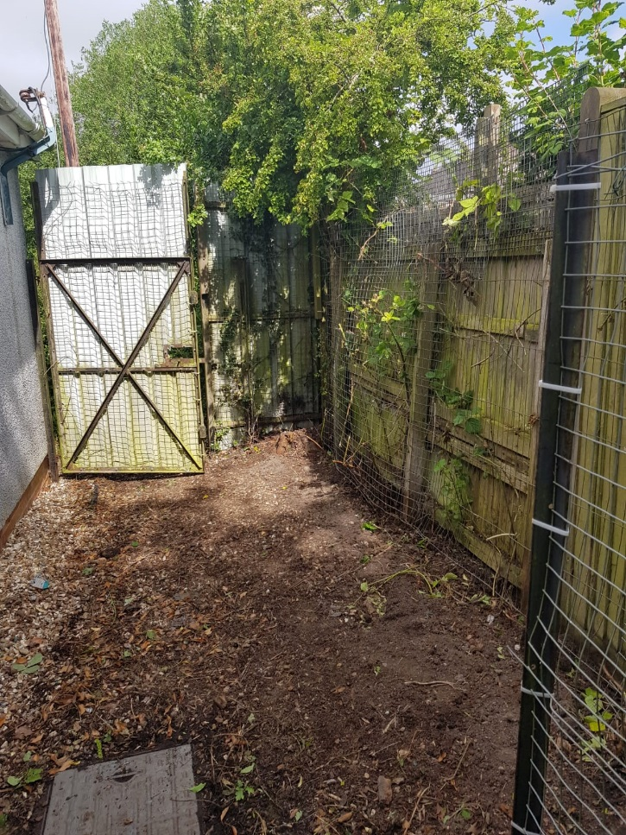 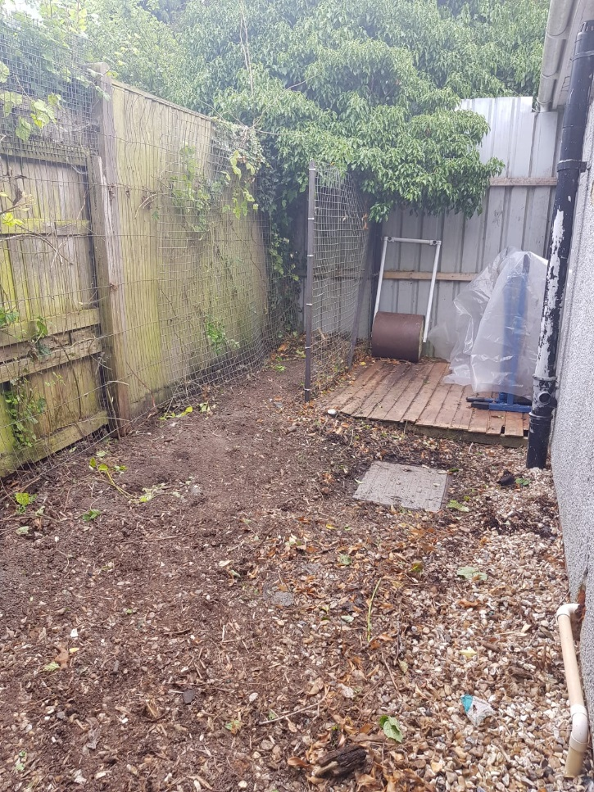 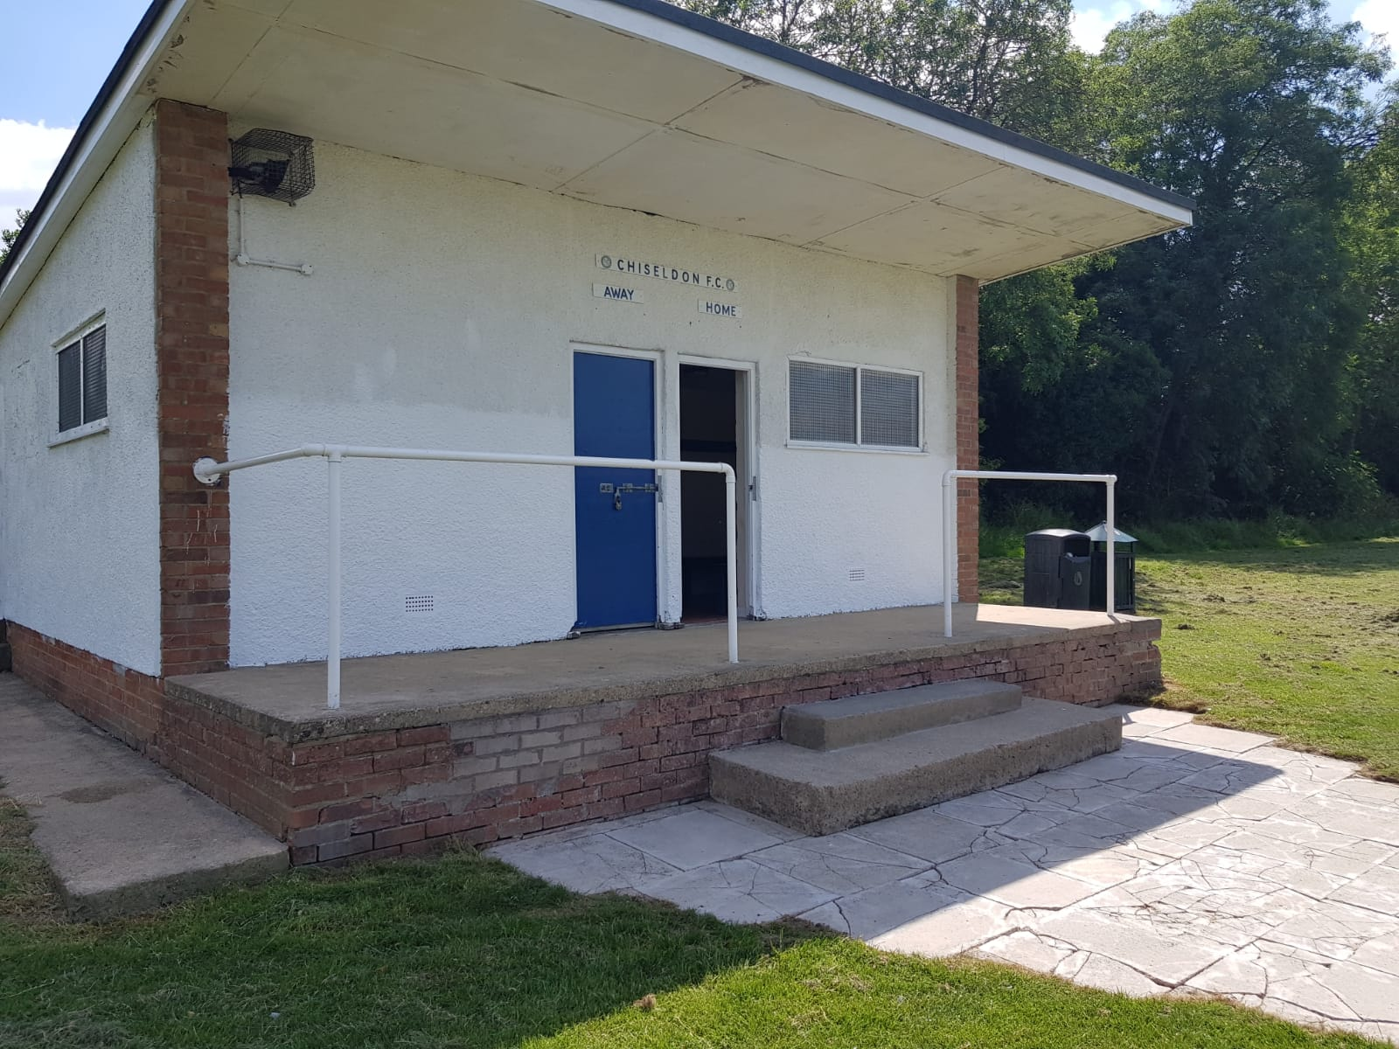

* Concern at the quality of grass cutting, last cut seemed better but not amazing.

*Club and Cllrs to report any issues to Clerk immediately so this can be taken up with the contractor.*

* If the club funded, what would need to be done to erect permanent brick dugouts at the Rec (on site of existing footings but would need to be bigger).

*CPC requested a more detailed design sketch so this can be considered. No planning permission is required unless over 4 meters tall. There is no objection to the club exploring this further and reporting back*

Example dug out 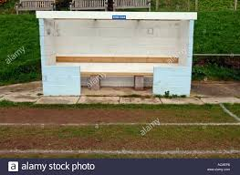

* New season due to start in September, friendly matches and training to resume in August.

The Club are also going to create their own signage that can go on the reverse of the CPC sign.

Matt Clarke leaves 20.26

**19/63. VILLAGE APPEARANCE – Collection bin request from SCOPE**

The committee had received the correspondence from a third party and were in agreement that a suitable place on parish land wasn’t available without causing a nuisance to residents.

**19/64. New bin for Draycot Foliat**

Costs are:

Approx £157 for a bin, £50 to install it and £130 a year to empty it once a week.

**A motion was raised by Cllr Sunners to approve these costs for a new bin for Draycot Foliat. Cllr Rogers seconded and all Cllrs in favour.**

This will now go to Finance committee for final approval

**19/65 VILLAGE APPEARANCE – New Planter for Norris Close**

The police visited Norris Close to advise residents against driving on the green area and pavements. The police recommended the bollard be re-installed on the corner of the green area. The PC felt a planter would do the same job, cost less and be a pleasing addition.

Costs are £105 for a triangle wooden planter and soil, secured to the ground.

**A motion was raised by Cllr Jefferies to approve these costs for a new planter in Norris Close. Cllr Rogers seconded and all Cllrs in favour.**

This will now go to Finance Committee for final approval

**19/66 BUILDING & AMENITY PRIORITIES – Tennis Club report**

The report from the club was read out by the Cllr Rogers.

League matches are nearing the end now but we will have a few to play that didn’t get played because of inclement weather.

It works better with the Softball people opening the gate but we are making signs to put up in the car park to save a few places for the tennis near the courts.

I hope the grounds people will cut the weeds along the top of court 3 ( public court)

We have our key code lock in place now on the clubhouse door. It seems to be working very well.

Mr Paul Walton is getting prices to improve the drainage for the August meeting.

**19/67 - BUILDING & AMENITY PRIORITIES – Pavilion**

Nothing to report

**19/68 – BUILDING & AMENITY PRIORITIES –Allotments**

Nothing to report

**19/69. BUILDING & AMENITY PRIORITIES – Rec hall, ground and carpark**

Nothing to report

**19/70 BUILDING & AMENITY PRIORITIES – CVPA.**

Nothing to report

**19/71 – BUILDING & AMENITIES PRIORITIES – Vote on single gate at SHCMG**

The 2 quotes had been received by the committee prior to the meeting

**A motion was raised by Cllr Jefferies to approve the costs of £448 plus vat for Allbuild to supply and fit the new gate. Cllr Rogers seconded and all Cllrs in favour.**

**19/72 Vulnerable people and BIOS**

Memory café - the church has extended the hall use for a further 6 months free of charge.

Cllr Sunners to attend the Community workshop being held.

Cllr Jefferies provided an update on the bus service. Children and care home staff can now get to and from Marlborough now due to the Salisbury Reds taking over this service. It will be a partially funded service for school children. It is scheduled for 1 year and will then be reviewed by the bus company.

**19/73 Items for next agenda**

Extra security needed for Rec garage

The meeting closed at 20.52

**Next meeting:** Monday 19th August 2019 at **7.30pm** in the Old Chapel, Butts Road.

***SUMMARY OF ACTION POINTS***

|  |  |  |
| --- | --- | --- |
|  |  |  |
| **Clerk** | *18/137*  *19/13*  *19/50*  *19/61*  *19/62*  *19/64 & 65*  *19/73* | Monitor properties at Turnball & Slipper Lane for overgrown foliage into road and write letters if needed.  Add item to July/Aug agenda ref rolling new carpark at Rec  Finance committee to approve costs of £125.00 for STORM to fix leak at Rec hall. Ongoing as quote may change.  Do follow up note to residents in regards to Strouds Hill seating  Get green waste leaflet from SBC for Ridgeway View  Reply to resident ref W.Cllr Jefferies investigating  Contact landowner ref grass cutting next to Aisne Road  Pass to Finance, approval of costs on item 19/64 and 19/65  Get quotes for extra locks on Rec hall garage |