CHISELDON PARISH COUNCIL

Contact details:
Clerk – 01793 740744 clerk@chiseldon-pc.gov.uk

Planning, Transport Development and Highways Committee

meeting at the The Old Chapel, Butts Road, Monday 3rd June 2019 at 7.30pm
AGENDA

- Vote in New Chair of the committee – Cllr Jefferies to take this item as current VC

- Vote in New Vice Chair of the Committee (If required)

- Attendances and apologies for absence

- Declarations of Interest

- Public Recess

6. Approval OF MINUTES from the meeting on 25th March & 15th April 19

7. Action Points

8.  9.  10.  11.  12.  13.  14.  15.  16. | PLANNING  VOTING ITEMS  Discuss & Vote on planning application S/HOU/19/0679 for 23 Norris Close.  Discuss History Group adding another Interpretation board outside the church. Feedback requested. See additional information  Review planning list of current planning applications.  Discuss possible application from Redlands Airfield for 2nd plane to fly. (CPC are not a consultee on this)  TRANSPORT DEVELOPMENT  Discussion on Wilts Council possibly cancelling service 80 into Marlborough in the morning (bus used by school children) See additional documentation.  HIGHWAYS  Double Yellow Lines on Slipper Lane/Turnball junction – update from Clerk  Dykes Mews parking issue – discuss, plus any update received from Ward Cllrs. Updated requested from WC’s 22.5.19  Request from Draycot Foliat for painted parking bays and possibly extra parking created on green area. WC’s chased for a possible cost for CPC to create parking bays. 22.5.19.  Funds allocated to 2020/21 budget, or funds from general reserves – possible request to be made to Finance Committee.  Items for next agenda  (Note, these items cannot be voted on at this meeting)
Next meeting Monday 22nd July 2019 at 7.30pm in The Old Chapel, off Butts Road.
Signed: C Wilkinson (Clerk)
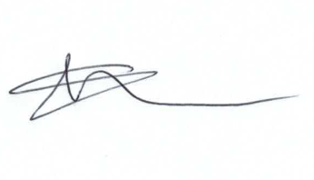
Supplementary Agenda information:

Committee members: Chris Rawlings, Jenny Jefferies, Ian Kearsey, Matt Harris.

Please note this meeting may be recorded.

Public notice – if you comment during public recess at a council meeting your personal details (such as name and address as relevant) will be recorded on the minutes. Please advise the Clerk at the time of speaking if you do not wish your personal details to be noted. Please see our privacy policy on www.chiseldon-pc.gov.uk for full details of how we store & manage data.

