CHISELDON PARISH COUNCIL

Contact details:
Clerk – 01793 740744 clerk@chiseldon-pc.gov.uk

Interim Planning, Transport Development and Highways Committee

meeting at The Old Chapel, Butts Road, Monday 15th April 2019 at 7.30pm
AGENDA

- Attendances and apologies for absence

- Declarations of Interest

- Public Recess

VOTING ITEMS

- 39 Home Close. Single storey side and rear extension & conversion of garage. S/HOU/19/0476

- Burderop Park. Demolition of the pavilions, change of use of offices and ancillary buildings to 25no. apartments/dwellings, erection of 52no. dwellings, construction of new access and associated works - Variation of condition 2 (Approved Drawings) following planning permission S/17/0128
S/19/0441

6.Items for next agenda
(Note, these items cannot be voted on at this meeting)

Next meeting Monday 3rd June 2019 at 7.30pm in The Old Chapel, off Butts Road.
Signed: C Wilkinson (Clerk)
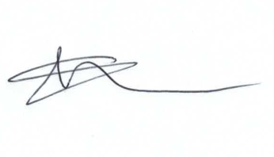
Supplementary Agenda information:

Committee Members: Caroline Brady (Chair), Chris Rawlings, Jenny Jefferies (Vice Chair), Ian Henderson, David Hill, Matt Harris, Andrew McDonald, Phil Costigan, Glenn Mills.

Please note this meeting may be recorded.

Public notice – if you comment during public recess at a council meeting your personal details (such as name and address as relevant) will be recorded on the minutes. Please advise the Clerk at the time of speaking if you do not wish your personal details to be noted. Please see our privacy policy on www.chiseldon-pc.gov.uk for full details of how we store & manage data.

