CHISELDON PARISH COUNCIL

Contact details:
Clerk – 01793 740744 clerk@chiseldon-pc.gov.uk

Environment, General Purpose and Amenities Committee
meeting at the Old Chapel, Butts Road, Monday 18th February 2019 at 7.00pm

AGENDA
1. | 7.00PM – Presentation from STORM on CCTV option for Rec Hall.  PFS unable to attend an evening meeting. Questions to be compiled for them ref their quote  Attendances and apologies for absence
2. | Declarations of interest
3. | Public recess
4. | Approval of minutes of meeting held 21st Jan 2019
5. | Matters arising not on the agenda  Action points
6.  7.  8.  9.  10.  11.  12.  13.  14.  15.  16.  17.  18. | WARD CLLRS UPDATE – Outstanding works within the Parish (List circulated before the meeting)  PARISHING PROGRESS  Settlement Boundary Review  Open Spaces Review  VILLAGE APPEARANCE  No issues  BUILDING & AMENITY PRIORITES  - TENNIS CLUB  - Tennis Club representative to update Committee  PAVILION  No items  ALLOTMENTS – Cllr Clarke to chair this item.  For Info -3 plots free still. (2 recently given up)  REC GROUND & CAR PARK  Quotes to be reviewed and decision taken if possible.  Discussion on reducing height of trees at Rec field – action for all Cllrs from last meeting  - CVPA  No items  CEMETERIES  No items  COMMUNITY PRIORITIES  - FOOTBALL MATTERS  Club representative to update Committee.  - VULNERABLE PEOPLE AND BIOS  ANY OTHER BUSINESS  (Note, items in AOB cannot be voted on)  9
Next meeting: Monday 18th March 2019 at 7.30pm in The Old Chapel, off Butts Road

Signed: C Wilkinson (Clerk)
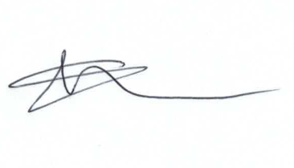
Current Committee:
Chris Rawlings (Chair), Caroline Brady, Keith Bates, David Hill, Andrew McDonald, Jenny Jefferies, Matt Clarke (Vice Chair), Paul Sunners, Paul Walton, Michelle Harris.

Additional Information

