CHISELDON PARISH COUNCIL

Contact: clerk@chiseldon-pc.gov.uk Tel 01793 740744

TRANSPORT & STRATEGIC PLANNING COMMITTEE MEETING
at the Recreation Hall on Thursday 23rd March 2017 at 7.30pm.

AGENDA

- ATTENDANCES AND APOLOGIES FOR ABSENCE.

2. DECLARATIONS OF INTERESTS

3. PUBLIC RECESS

3A. MINUTES AND ACTION POINTS

4. VOTE ON THE NAME OF THE COMMITTEE

5. COMPLETE AND VOTE ON THE COMMITTEES TERMS OF REFERENCE

6. DISCUSS WHAT INPUT CAN BE PROVIDED FROM WARD CLLRS AND SBC

7. REVIEW LOCAL MAPS AND DATA PRODUCED FOR CYCLE AND BUS ROUTES AND THE DRAFT DOCUMENTS SHOWING THE DIVISION OF PARISH IN REGARDS TO ISSUES.

8. REVIEW ANY TRANSPORT DATA RECEIVED.

9. PROPOSE AND VOTE ON THE APPOINTMENT OF PLANNING TRANSPORT/HIGHWAYS PLANNING CONSULTANT TO SUPPORT THE COMMITTEE – IF NEEDED

10. AOB

The next Transport Committee meeting will be held on 25th May at 7.30pm in the Old Chapel.

Signed: Parish Clerk

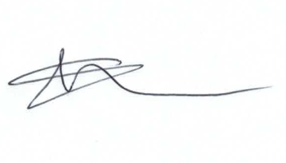
Committee members: Glenn Mills (Chair) John Martin (VC) Jane Beaumont, Caroline Brady, Ian McMurray, David Hill, Paul Walton

