CHISELDON PARISH COUNCIL

MINUTES of the PARISH COUNCIL MEETING
held on Monday 13th March 2017 at 7.30pm
in the Recreation Hall, Norris Close, Chiseldon
Present: Cllrs Caroline Brady (Chair), David Hill, Jenny Jefferies, Ian McMurray, Chris Rawlings, Matt Harris, John Martin, David West, Keith Bates, Jane Beaumont, Ian Henderson, Phil Costigan, Glenn Mills, B Cllr E Shaw, B Cllr F Foley and B Cllr G Sumner.
Apologies: Cllrs Paul Sunners and Cllr Paul Walton

Also in attendance: 4 members of the public

Public Recess

Mr David Pearse asked about the forthcoming 43% increase in band D Council tax precept figures for the coming year and the fact that the council tax precept for last year also increased.

Cllr Brady asked Mr Pearse if he had read the documentation on the parish website as this is a comprehensive report and explained why the increase was necessary and how it is being allocated. It also explained the fundamental basis over the last 2 years for the precept increase, which has been driven in response to Swindon Borough Council Strategy of transferring increasing number of environmental services down to Parish Council level. Mr Pearse does not believe the SBC strategy will prove to be as efficient..
A list was distributed of all the Precept charges the Parishes in the borough are making and where Chiseldon Parish Council appears on the table.
Cllr Brady advised that since taking on Parishing responsibilities CPC have negotiated a very competitive contract with our preferred contractor, which has proven to provide an excellent service tailored to our needs.
Mr Pearse was advised to ring the Clerk, Chair of Finance or the Council Chair with any other queries he had on the precept. Mr Pearse was also invited to attend the forthcoming Finance committee meeting on the 29th March to ask any further questions on the precept increase following his review of the information available on the Parish Website
Mr Pearse further commented on the 1.9% increase of policing funding yet hasn’t seen any police in the area and the Bell always reports a long list of crimes each month. Mr Pearse was invited to attend the Annual Parish meeting on the 19th April to listen to talk being given by Angus MacPherson , the Police and Crime Commissioner
Cllr Mills also commented that due to SBC removing services, if the Parish Council’s do not undertaken the work, then who will.

16/104. Declarations of interests.

2 planning applications for Cllr I McMurray

16/105. Approval of minutes from 13th February 2017

Page 2 – Amend Ward Cllr Sumner’s name

The minutes were proposed as approved by Cllr D Mills, seconded by Cllr I McMurray and all those at the meeting were in favour.

16/106. Matters arising and action points:

Matters arising:

None

Action Points:

Clerk Action Points on external bodies – ongoing. Cllr Foley is going to get the list that Highworth use for the Clerk to reference.

All other actions completed.

16/107 Ward Councillors reports.

Cllr Sumner:

Road sign on A346 that is leaning over. SBC have been chased several times now. The hedge affecting this has now been cut and the potholes in Badbury are to be repaired shortly and the sign washed. However SBC have not got it as a priority issue.
Suzanne Coles at SBC has confirmed that in due course speed strips will be placed in Badbury to monitor rat runs.
The other end of Medbourne Lane is to have a no HGV sign added, Suzanne Coles has confirmed.

Cllr Jefferies asked if air pollution can be monitored on the A346 down to J15. W Cllr Sumner advised that this can form part of the next J15 meeting with SBC. There is no date set for this meeting yet.

Cllr Shaw and Cllr Foley:
A written report was provided which the Clerk has made available to all Cllrs. Members of the public can request this report from the Clerk also.

Ward Cllr Shaw reported that SBC Highways and Streetsmart staff numbers have been reduced as a result priority is being given to dangerous situations.

There is a query about the track sign leading off of Hodson Road down to Messel Villa. Ward Cllr Shaw needs to talk to SBC to see who is responsible for the potholes on this track.

The mud on the paths at Slipper Lane has been caused by a separate building issue and not by the Manor House development. Planning enforcement has visited.

Cllr Jefferies reported that the path along the A346 towards the M4 was very overgrown. Ward Cllr Shaw is to ask SBC to clear this. He will also ask why there is no street lighting along the Marlborough road.

(Note – Item 3 on the image below refers to Chiseldon First)
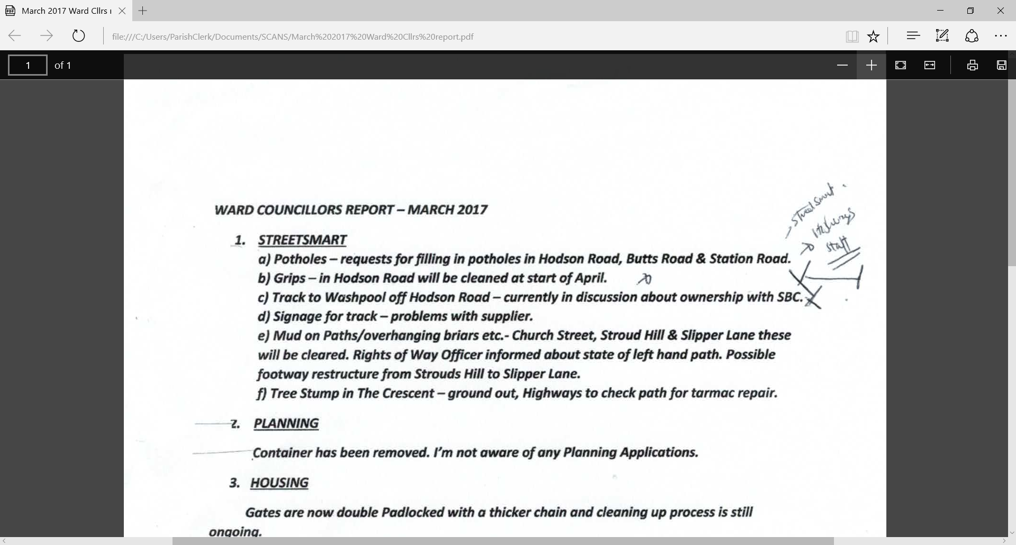

Ward Cllrs Shaw and Foley will also find out why SBC vans were at the location of the Build Out in New Road.

The container outside the Esso Station has been removed. A separate planning proposal is being submitted for a permanent structure to be built in its place

Ref the council owned houses and land on New Road - SBC officers have been seen measuring the stretch of green area outside these premises - Ward Cllr Shaw has advised that this area is expected to be changed from grass to hard standing before parking places are created.

Cllr Hill noted that after 4 months the bus stops on the new Wroughton route have not been installed. He has reminded Nigel Hale of this. Cllr Hill to send the plans to Cllr Foley who can talk to Nigel Hale about this.

16/108 Discussion about defibrillators within the Parish

Ward Cllr Sumner noted that Wanborough had 3. There is no training required and when you call 999 you are given a code to open the box. Wanborough spent between £5/6K getting them installed plus yearly maintenance costs.
Cllr Beaumont had contact HeartSafe Swindon and has information on costs and also has information from St Johns on how to use them. She will pass this to the Clerk.

It was discussed that local businesses and schools may want to contribute. It would seem important to have one on the Recreation ground.
The Council would like to support this initiative and explore further.
Cllr Rawlings will talk to the scout executive meeting about this

This will be taken to the Finance Committee for review and will then come back to Full Council.

The Clerk is to add comments on FB and website as to the current nearest location of defibrillators.

16/109 Police Report

There were 3 recorded incidences for Feb 2017. The Clerk read out the report supplied by PC Sophia Best.
Need to remind all residents to keep vehicles and homes secure.
The bus shelter on the A346 school side has been vandalized and has been reported to the police.
Ward Cllrs now leave the meeting at 20.16

16/110 Approval and vote on update of Standing Orders

The document was reviewed and a resolution carried that the amendment on page 9 section 41C be accepted by Full Council. This document is now the new working version.

16/111 Discussion and vote on new Parish logo

Cllr Harris advised on the background to this and how the school had been approached for ideas. A winning school design was chosen and our website developers came up with 6 options in total.
The Council voted via written vote on their favour design.
Design 2 which was a reworked colour design of the original logo won with 6 voted in favour.

Cllr McMurray proposed a resolution that the council accept design number 2 as it’s new Parish logo. Cllr Costigan seconded this and the vote was carried by a majority.

16/112 – Review of Committee minutes and documents

Finance: There has been no finance meeting since the last Full council meeting. Next one is 29th March. The Feb 2017 figures were reviewed.
Line 11 – Clerk to check and amend if required whether the football team pay VAT on their invoices.
Once this has been resolved Cllr Rawlings proposed a resolution that these figures be accepted as accurate. Cllr Costigan seconded. All those at the meeting in favour.

Environment: Cllr Rawlings reported that MP Robert Buckland has been contacted about the yellow lines on Hodson Road. The Ward Cllrs are also working on this so there is no need for the PC to continue with this matter as it is in hand.
Allotments still have some areas to be cleared. Cllr Rawlings and Cllr Walton to visit the site as some plots are going over the boundary areas.

Transport report from Cllr Hill:
The Stagecoach service 5 finishes on 26th March.
81 and 80 service changing in April due to customer feedback. The 5.25 service is moving to 5.55.
Cllr Hill has requested a meeting with Gloucester and Swindon Managers to ask for the service within Chiseldon to be amended to go through the village.

Recreation:
Nothing to report. There is no Recreation meeting in March.
Cllr Brady commented on the Tennis club agreement to provide 50/50 payment for fence repairs. No more screens are to be erected without an engineer report that it is safe to do so and what supporting structure would be required .
The PC is looking to upgrade current insurance levels for the TC and other assets. We will also review the TC lease to reflect accurately the level of insurance cover and clarify the clauses on permissions . The TC have been requested at the April meeting to present their financial plans for t the future maintenance of the courts as outlined in the lease.

Planning:
Few plans at the moment. We are still waiting to hear about Burderop Park.

Badbury Park: Cllr West reported that the Badbury Park Community Association will step down in April as the representatives for Badbury Park. Ward Cllr Foley will be assisting with the transition to the new parish.

Transport and Strategic planning: The remit and actions of this new committee will be finalised in the March meeting.

It was clarified that the Environment committee would continue to look at existing issues until the final remit of the new committee was finalised.

16/113. AOB
Cllr Jefferies commented on the lack of community fund raising. Do we need to establish links with Liddington Parish so that the 2 communities could work more closely on fund raising? This is to be scheduled for the next Recreation meeting.
Cllr Beaumont wants to encourage local groups to run the coffee morning sessions. They can then take the money made for their own charities.
Cllr Hill commented that the yellow bin near the Spar wasn’t emptied today. Clerk to ask AllBuild.
Cllr Hill advised that the library at Wroughton will close on the 31st March for a week and then open the following Friday. The details are in the Ridgway Bell.
The meeting closed at 20.56
Date of next meeting. The next meeting date is Monday 10th April 2017 at 7.30pm. It will be held in the Recreation Hall off Norris Close.
SUMMARY OF ACTION POINTS.
All Actions to be completed by the next Full Committee meeting unless otherwise specified.
Clerk  Cllr Hill  Cllr J Beaumont  Cllr Rawlings  Ward Cllr Shaw | Action points  16/108  16/108  16/109  16/112  16/113  16/113  16/107  16/108  16/108  16/107 | Check what external bodies the PC should belong to, such as Rights of Way and Walkers Assoc’s. Long term action point.  Add defibrillator costs review to the Finance agenda  Add to FB and website the closest current defibrillators  Remind all residents via FB and website to keep homes and vehicles secure.  Update Xero with VAT details on football club payment  Add community fund raising with other parishes to the next Recreation meeting  Ask Allbuild about bin near Spar being emptied regularly.  Send plans of bus stop on Wroughton route to Ward Cllr Foley so she can talk to Nigel Hale about new stops.  Pass on defibrillator information to the Clerk  Talk to the Scouts executive committee about defibrillator possibly being sited on the Memorial Hall  Query SBC on whether A346 towards M4 should have street lighting for houses along this road. Also ask SBC why SBC vans were at the location of the Build Out on New Road.

