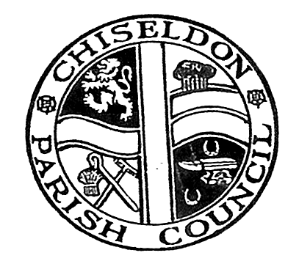

CHISELDON PARISH COUNCIL

PARISH COUNCIL MEETING
at the Recreation Hall on Monday 13th February 2017 at 7.30pm.

AGENDA
Papers ;
included

PUBLIC RECESS - to receive questions and comments from the public on Council related matters. Members of the public are allowed to address the Chair for 5 minutes. No decisions will be taken at this meeting. Maximum 10 minutes

1. ATTENDANCES AND APOLOGIES FOR ABSENCE

2. DECLARATIONS OF INTERESTS

4. APPROVAL OF MINUTES of the Full Council meeting from 9th January 2017.

5. MATTERS ARISING AND ACTION POINTS

6. SWINDON BOROUGH COUNCIL REPORTS FROM WARD CLLRS

7. HEATHER FROM THE NATONAL FLOD FORUM PRESENTATION

8. POLICE REPORT

9. NEW PARISH COUNCIL LOGO UPDATE FROM CLLR SUNNERS

10. LIBRARY UPDATE FROM CLLR HILL

11.COMMITTEE AND REPRESENTATION REPORTS
FINANCE – to include vote on new Financial Regulations document
ENVIRONMENT
TRANSPORT UPDATE
RECREATION
PLANNING
BADBURY PARK – David West

12. PARISH XMAS LIGHTS FOR 2017

13. MARCH 4th LITTER PICK LEAFLET DELIVERY

13. AOB

N.B - Correspondence to be emailed due to time constraints

The next Full Council meeting will be on Monday 13th March 2017 at 7.30pm in the Recreation Hall.

