CHISELDON PARISH COUNCIL

Contact Clair Wilkinson – Clerk
Tel 01793 740744. clerk@chiseldon-pc.gov.uk

RECREATION & COMMUNITY COMMITTEE
meeting on Monday 22^{h} May 2017 at The Recreation Hall off Norris Close at 7.00pm

AGENDA

- Vote in New Chair and Vice Chair of the Committee

- Attendances and apologies for absence

 | - Declarations of interest
- Public recess
members of the public may address the Committee on any Recreation related matter for a maximum of five minutes
 | - Approval of minutes of meeting held on 24th April 2017
 | - Matters arising (not elsewhere on the agenda)/ Action points
 | - Football matters | Discussion with Matt Clarke/James over Lease for Football Club pavilion and any pitch improvement updates.
 | - Tennis Club | Emailed update received from Julie
 | - Castle View play area (CVPA) / teen area | Update on CVPA repairs
 | - Pavilion (items not addressed under Football matters) | Pavilion frost heaters fixed.
 | - Recreation Ground
 | - Recreation Hall | Security system at Rec Hall.
 | - Youth activities
- Care of vulnerable people

- Review draft Terms of Reference document and provide amendments if required. Vote on final version.

 | - Any other business

Date of next meeting: Monday 19th June 2017 at 7.00pm in The Old Chapel, Butts Road.

Signed: C. Wilkinson (Clerk)
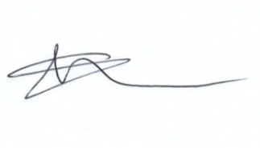
Committee Members: Paul Sunners (Chair), Paul Walton (VC), Ian McMurray, Keith Bates, Jenny Jefferies, Caroline Brady.

