CHISELDON PARISH COUNCIL

Contact: clerk@chiseldon-pc.gov.uk Tel 01793 740744

TRANSPORT DEVELOPMENT COMMITTEE MEETING
at the Butts Road Chapel on Thursday 27th July 2017 at 7.30pm.

AGENDA

- ATTENDANCES AND APOLOGIES FOR ABSENCE.

2. DECLARATIONS OF INTERESTS

3. PUBLIC RECESS

4. MINUTES from 23rd May 2017

5. MATTERS ARISING AND ACTION POINTS

6. REVIEW COLLATED DOCUMENT SHOWING THE DIVISION OF PARISH IN REGARDS TO ISSUES. (Cllr Brady to provide information)

7. REVIEW ANY TRANSPORT DATA RECEIVED. M4 J15 Modelling.
Plus review Highways England and SWLEC comments for J15/J16 funding comparisons and effect on Wroughton when M4 closed.

8. PROPOSE AND VOTE ON THE APPOINTMENT OF PLANNING TRANSPORT/HIGHWAYS PLANNING CONSULTANT TO SUPPORT THE COMMITTEE – ref Jason Humm New Road build out email reply.

9. DISCUSS MERITS OF TURNBALL BEING MADE A ONE WAY STREET. Possible vote.

10. AOB
(Note, items in AOB cannot be voted on)

The next Transport Development Committee meeting will be held on
Thursday 28th September in the Old Chapel, off Butts Road.

Signed: Parish Clerk
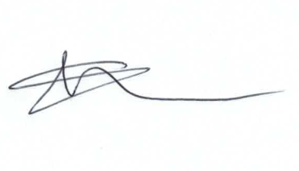
Committee members: Glenn Mills (Chair) John Martin (VC), Caroline Brady, David Hill, Paul Walton

