CHISELDON PARISH COUNCIL

Contact Clerk on 01793 740744 or clerk@chiseldon-pc.gov.uk

Finance Committee
meeting at the Recreation Hall, off Norris Road Wednesday 26th April 2018 at 7.30
AGENDA
1 | Attendances and apologies for absence
2 | Declarations of interest
3 | Public recess
4 | Approval of minutes  (From 29th March 2018)
5  6 | Matters arising not on the agenda  Action points  Review Accounts for April 2018 to date
7  8  9  10  11 | Vote on Environment request to spend £300 on 10 new Neighbourhood Watch signs.  Review and possibly vote on further expenditure to approve and repair CVPA.  Review and approve expenditure for heating repairs and improvements to Pavilion.  Review and vote on expenditure of Clerks next course.  Review and add any amendments to Financial Regs before they are approved by Full Council on 8th May  Any other business.  Next meeting: 31st May 2018
Signed by Clerk:
C. Wilkinson
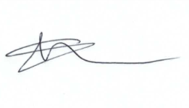
Current Committee: Matthew Harris (Chair), Phil Costigan, David West (vc), Caroline Brady, Paul Walton, Ian Henderson, Jane Beaumont.

