CHISELDON PARISH COUNCIL

Contact details:
Clerk – 01793 740744 clerk@chiseldon-pc.gov.uk

Environment, General Purposes & Highways Committee
meeting at the CHAPEL, BUTTS ROAD, Thursday 17th August 2017 at 7.00pm

AGENDA

1. | Attendances and apologies for absence
2. | Declarations of interest
3. | Public recess
4. | Approval of minutes of meeting held 13th July 2017
5. | Matters arising not on the agenda  Action points
6. | Allotments
7. | Dog bins
8. | Highways
9. | Street furniture
10.  11.  12. | Village appearance  Cemeteries & Chapel/Museum  Environmental Services | Discussion & vote on proposal to get both sets of Chapel doors (Museum included) repainted.
13.  14.  15. | STORM Facilities Management tender  Tree report from Rec ground  AOB. (Note, items on AOB cannot be voted on) | Vote on purchases for Allbuild – 2 x hi-vis jackets £16.05 each with logo  2 x magnetic vehicle signs - £35.40 for 2 inc VAT from Enterprise works.  Jackets and signs to show CPC and Allbuild logo, working in partnership.  Any update following full council meeting on 14th  Report back on SBC advice if any progress made

Next meeting: TBC 2017 at 7.00pm in The Old Chapel, off Butts Road

Signed: C Wilkinson (Clerk)

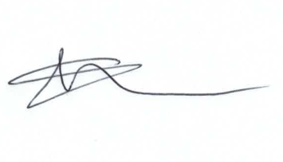
Current Committee:
Chris Rawlings(VC), Keith Bates, Caroline Brady, Glenn Mills, Matthew Harris, David Hill, Paul Walton, David West (Chair), Paul Sunners, John Martin,

