Contact Clerk on 01793 740744 or clerk@chiseldon-pc.gov.uk

CHISELDON PARISH COUNCIL

Finance Committee
meeting at the Recreation Hall, off Norris Road Wednesday 29th March 2017 at 7.30

AGENDA

1 | Attendances and apologies for absence
2 | Declarations of interest
3 | Public recess
4 | Approval of minutes  (From 25th January 2017)
5  6 | Matters arising not on the agenda  Action points  Review Accounts for March 2017
7  8  9  10  11  12  13  14  15  16  17  18  19 | Vote on payment of £50.00 to hire Chiseldon House hotel for Annual Parish meeting plus £3.00 pp for tea/coffee.  Vote on Clerk’s salary increase and back dated payment. Cllr Brady to provide details  Vote on Environment committee request to spend a sum of money as a donation for the Primary School as a thank you for their Parish logo work. Amount of money to be approved.  Vote on Environment Committee request to spend £286 on a larger bin for opposite Oakleys Spar.  Vote on Environment Committee request to spend £530.00 plus paint costs to maintain the BT phone box at Badbury which CPC now own  Vote on Environment Committee request to spend £6200.00 on the quote from Allbuild to create a new chapel ceiling, internal wall and associated works for heating, plastering, painting and lighting.  Vote on Environment Committee’s approval of the new parishing items to be taken on. Finance Committee to approve new yearly costs as they currently stand with Allbuild.  Vote to renew the Clerks SLCC membership for a further year - £121.00, due 1st May  Approve purchase of a fire proof box/safe for important documents. Cost TBC  Vote on Environment committee request to spend £145.00 plus VAT on work from Alluild to cut down the ivy from the base of our large trees to prevent tree damage during high winds.  If required, vote on Environment Committee quote of £1100.00 from AllBuild to clear back the land at Strouds Hill of brambles and scrubland.  Discussion and possible vote on how much the Parish Council should spend on defibrillators for the Parish. Approx cost £2000 per machine plus annual maintenance costs. To be taken back to Full Council.  Any other business.  Next meeting: 31st May 2017

Signed by Clerk:
C. Wilkinson
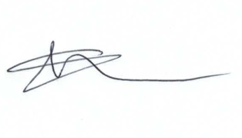
Current Committee: Matthew Harris (Chair), Phil Costigan, David West (vc), Caroline Brady, Paul Walton.

