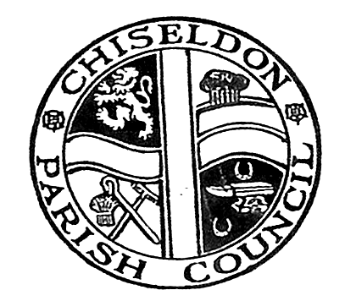

CHISELDON PARISH COUNCIL

Environment, General Purposes & Highways Committee
meeting at the Recreation Hall, Norris Close, Thursday 15th December 2016 at 7.15pm

AGENDA

 | Attendances and apologies for absence
 | Declarations of interest
 | Public recess
 | Approval of minutes of meeting held on 17th November 2016
Matters arising not on the agenda
Action points

 | Allotments
6 | Dog bins
7 | Highways | Resident request to get traffic lights on M4 roundabout altered to allow more traffic through from Plough Hill – what action for CPC?
8 | Street furniture | A further new bin for A346 bus stop on School side.
9  10  11 | Village appearance  Cemeteries  Environmental Services | Resident in Badbury has requested a litter pick that they will take part in – part of a National campaign.  Quote for iron railings received for discussion from AllBuild
12 | Any other business | Tesco funding. Monies used from 5p bag charge for community projects – of any use?  Library Consultation Update  Review of document from the Langton Estate
Next meeting: Thurs 12th Jan 2017 at 7.15pm in The Old Chapel.

Current Committee:
Chris Rawlings (Chair), Keith Bates, Caroline Brady (vc), Glenn Mills, Matthew Harris, David Hill, Paul Walton, David West, Paul Sunners, John Martin.

