CHISELDON PARISH COUNCIL

Contact details:
Clerk – 01793 740744 clerk@chiseldon-pc.gov.uk

Planning, Transport Development and Highways Committee
meeting at the RECREATION HALL, Monday 22nd January 2018 at 7.30pm

AGENDA

1. | Attendances and apologies for absence
2. | Declarations of interest
3. | Public recess
4. | Approval OF MINUTES from the meeting on Thursday 21st December 2017
5.  6.  7. | Matters arising not on the agenda  Action points.  PLANNING  Sarah Screen from SBC Planning Dept attending to advise on CIL. (7.45)  Matt Moore from the Wroughton Science Museum attending to advise on their newest proposed plans. (8.00pm)
8.  9.  10.  11.  12. | VOTING ITEMS  - Review and Vote on new submitted applications.  - S/HOU/17/2101 26 Carisbrook Terrace.  - S/17/2029 – Chiseldon Primary School  - Review outstanding applications list BY EXCEPTION  HIGHWAY ITEMS  Nothing to report  TRANSPORT DEVELOPMENT ITEMS  First review of draft document for top 6 Highways issues within the Parish  99  ANY OTHER BUSINESS  (Note, items in AOB cannot be voted on)
Next meeting: Monday March 26th 2018 at 7.30pm in The Old Chapel, off Butts Road
Signed: C Wilkinson (Clerk)
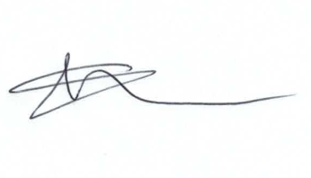

Supplementary Agenda information:

Plans S/HOU/17/0821 for 23 Hodson Road have been appealed and are with the planning inspectorate.

No decision made yet (from 17th Jan) on Whichway Cottage, Badbury.

Clerk has asked Andy Brown at SBC for any update on:
New Road proposed planning application
Whichway Cottage Badbury going to SBC Planning Committee
Invitation for SBC Conservation officer to visit future meeting to give a talk on procedures and decision making process.

Committee Members: Caroline Brady (Chair), Chris Rawlings (Vice Chair), Jenny Jefferies, Ian Henderson, David West, David Hill, Matt Harris, Andrew McDonald, Phil Costigan, Glenn Mills.

