CHISELDON PARISH COUNCIL

Contact details:
Clerk – 01793 740744 clerk@chiseldon-pc.gov.uk

Environment, General Purpose and Amenities Committee
meeting at the Chapel, Butts Road, Monday 16th July at 7.30pm

AGENDA
1. | Attendances and apologies for absence
2. | Declarations of interest
3. | Public recess
4. | Approval of minutes of meeting held 25th June
5. | Matters arising not on the agenda  Action points
6.  7.  8.  9.  10.  11.  12.  13.  14. | PARISHING PROGRESS  - Fir tree in Badbury needs taking down over path. Resident has offered to divide cost 50/50. Total quote from Allbuild £300.00 plus VAT (No decision made in June)  - Does the council pay for an extra bin at the Spar – years cost would be £143.00  VILLAGE APPEARANCE  - ALLOTMENTS – no items to discuss  BUILDING & AMENITY PRIORITES  - TENNIS CLUB  - Tennis Club representative to update Committee  RECREATION HALL  - Plan for Rec carpark improvements. Start discussion and make a plan of action  - CVPA  - Spending some of 2018/19 budget.  £3000 on either replacing existing old equipment or purchasing new. See additional documentation for see saw purchase and bench costs approval.  COMMUNITY PRIORITIES  - FOOTBALL MATTERS  Club representative to update Committee.  - VULNERABLE PEOPLE AND BIOS  ANY OTHER BUSINESS  (Note, items in AOB cannot be voted on)  9
Next meeting: Monday 20th August 2018 at 7.30pm in The Old Chapel, off Butts Road

Signed: C Wilkinson (Clerk)
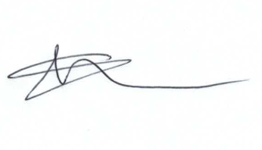
Current Committee:
Chris Rawlings (Chair), Caroline Brady, Keith Bates, David Hill, Andrew McDonald, Jenny Jefferies, Matt Clarke (Vice Chair), Paul Sunners, Paul Walton, Michelle Harris.

Additional Information

