CHISELDON PARISH COUNCIL

Contact details:
Clerk – 01793 740744 (Voicemail) clerk@chiseldon-pc.gov.uk

You are summons to the Planning, Transport Development and Highways Committee meeting.

Thursday 26th August 2021 at 7.30pm. At the Recreation Hall off Norris Close in Chiseldon. Remote login details at the end of the agenda for residents who may wish to attend remotely.

AGENDA
1

- Vote to approve Cllr Barnes joining the committee

- Attendances and apologies for absence. Absence with no apologies to be recorded separately. Vote on approval of apologies.

- Declarations of Interest and vote on any dispensations required.

- Public Recess. 10 minutes maximum, 3 minutes per speaker if multiple speakers.

- Approval of minutes from 29th July 2021

- Action points.

7.  8.  9.  10.  11.  12.  13.  14.  15.  16.  17.  18.  19.  20. | 2022/23 budget items. Committee to consider & discuss any items required for the 2022/23 budget. Final vote on items to be passed to Finance committee for consideration will be on the Sept agenda. See 2021/22 budget on MS Teams  Review April to July 2021 budget vs expenditure report for the planning committee. See report loaded into MS Teams  PLANNING: VOTING ITEMS  Discuss & vote on S/21/1125. Burderop Park.  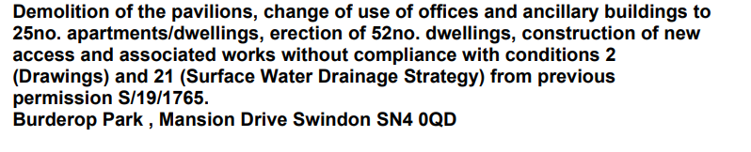  Discuss & vote on S/21/1126 Burderop Park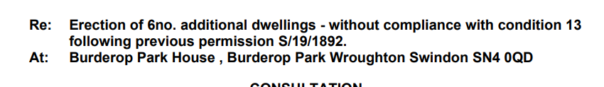  Discuss & vote on S/21/0326. REVISED. Unicorn Business Park. Erection of 5 units. B8/E(g) class. See updated information provided via email.  Discuss & vote on S/HOU/21/1047. Stocks Close. Badbury Lane. Badbury. Single storey side extension & porch to front. Render garage walls.  Discuss & vote on S/HOU/21/1073. 10 Home Close. Detached summer house.  Discuss & vote on S/HOU/21/1203. 10 Draycott Road. Pitched roof to garage & covert to habitable space.  Discuss & vote on S/21/1237. Draycot Farm. Draycot Foliat Lane. Change of use from agricultural to storage, distribution and offices.  Discuss and vote on reply to SBC revised Local Plan review, carried over from July 2021. See additional documentation  HIGHWAYS: VOTING ITEMS  Discuss & vote on future SID sites for Draycot Foliat and Hodson. (item requested by Cllr Duke)  Discuss & vote on whether to petition SBC to have traffic lights at the junction between New Road and the A346.  TRANSPORT: VOTING ITEMS - No items  Items for next agenda (Note, these items cannot be voted on at this meeting)

Next meeting Thursday 30th September 2021 7.30pm in the Old Chapel office, Butts Road Close, Chiseldon.
Signed: C Wilkinson (Clerk) 20.8.2021

Committee members: Cllr Matt Harris, Cllr Chris Rawlings, Cllr Ian Kearsey (Committee Chairman), Cllr Steve Duke (Committee Vice Chairman), Cllr Danielle Simpson, Cllr Jenny Jefferies, Cllr Patel.

LAW THAT ALLOWS THE COUNCIL TO VOTE/ACT:

N/a on this agenda.

Login details for the public:

https://teams.microsoft.com/l/meetup-join/19%3adbbacb08b20c40d085388ae5690a05cb%40thread.tacv2/1629285428539?context=%7b%22Tid%22%3a%22994eb4e1-2fcb-47f9-a34e-66c6767624a1%22%2c%22Oid%22%3a%22abfe080e-0d86-401d-95dd-e231c117cc34%22%7d

