CHISELDON PARISH COUNCIL

Contact details:
Clerk – 01793 740744 clerk@chiseldon-pc.gov.uk

Planning, Transport Development and Highways Committee
meeting at the The Old Chapel, Butts Road, Thursday 26th April 2018 at 7.00pm

ADDITIONAL MEETING AGENDA – PLANNING ITEMS ONLY

1. | Attendances and apologies for absence
2. | Declarations of interest
3. | Public recess
4. | Approval OF MINUTES from the meeting on Thursday 26th April 2018
5.  6. | Matters arising not on the agenda  Action points.  PLANNING
7. | VOTING ITEMS  - Review and Vote on new submitted applications.  - S/HOU/18/0661 for 11 Marlborough Road  - S/HOU/18/0218 and S/LCB/18/2019 for 16 Badbury – amended plans  - S/HOU/18/0573 and S/LBC/18/0574 for 26 Hodson Lane, Hodson  - S/18/0516 1 Butts Road  ANY OTHER BUSINESS  (Note, items in AOB cannot be voted on)
Next meeting: Tuesday 31st May 2018 at 7.30pm in The Old Chapel, off Butts Road (Monday is bank holiday)
Signed: C Wilkinson (Clerk)
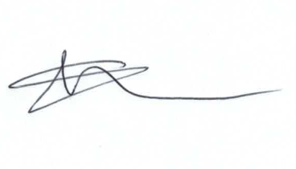

Supplementary Agenda information:

Committee Members: Caroline Brady (Chair), Chris Rawlings (Vice Chair), Jenny Jefferies, Ian Henderson, David Hill, Matt Harris, Andrew McDonald, Phil Costigan, Glenn Mills.

