CHISELDON PARISH COUNCIL

Contact: clerk@chiseldon-pc.gov.uk Tel 01793 740744

TRANSPORT DEVELOPMENT COMMITTEE MEETING
at the Chiseldon House Hotel on Tuesday 23rd May 2017 at 7.30pm.

AGENDA

- VOTE IN NEW CHAIR AND VICE CHAIR OFF THE COMMITTEE

- ATTENDANCES AND APOLOGIES FOR ABSENCE.

2. DECLARATIONS OF INTERESTS

3. PUBLIC RECESS

4. MINUTES from 23rd March AND ACTION POINTS

5. DISCUSSION TO ENSURE 24th MAY SBC MEETING DETAILS ARE FINALISED REF M4 J15.

6. REVIEW LOCAL MAPS AND DATA PRODUCED FOR CYCLE AND BUS ROUTES.

7. REVIEW AND COLLATE DOCUMENTS SHOWING THE DIVISION OF PARISH IN REGARDS TO ISSUES.

8. REVIEW ANY TRANSPORT DATA RECEIVED.

9. PROPOSE AND VOTE ON THE APPOINTMENT OF PLANNING TRANSPORT/HIGHWAYS PLANNING CONSULTANT TO SUPPORT THE COMMITTEE – IF NEEDED

10. AOB

The next Transport Development Committee meeting will be held on
Thursday 27th July in the Old Chapel, off Butts Road.

Signed: Parish Clerk
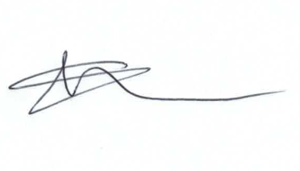
Committee members: Glenn Mills (Chair) John Martin (VC) Jane Beaumont, Caroline Brady, David Hill, Paul Walton

