CHISELDON PARISH COUNCIL

Contact details:
Clerk – 01793 740744 clerk@chiseldon-pc.gov.uk

Environment, General Purposes & Highways Committee
meeting at the CHAPEL, BUTTS ROAD, Thursday 15th June 2017 at 7.00pm

AGENDA

1. | Attendances and apologies for absence
2. | Declarations of interest
3. | Public recess
4. | Approval of minutes of meeting held 11th May 2017
5.  6.  7. | Matters arising not on the agenda  Action points  STORM facilities Management discussion  Final review & vote on positioning of the History Society board at Strouds Hill.
8. | Allotments | Discussion & vote on proposed new water tank for allotment. (Clerk is asking Allbuild for prices)
9. | Dog bins
10. | Highways | Request from resident to write to Mr Margesson about tractor speed in the village.
11. | Street furniture | Residents request for consideration for old railway signal machinery to be installed on New Road near allotments – historical feature – perhaps for next financial year?
12.  13.  14. | Village appearance  Cemeteries  Environmental Services | Clerk has number of hedge letters to write.  Discussion & vote on dealing with overgrown hedge cutting costs for a resident so Albuild can manage the grass verge underneath. There have been complaints about the overgrown nature of the area.  Resident has a complaint that grave digger threw away kerb stone edging as didn’t comply with cemetery regs – Clerk to advise on details. Vote needed on whether to disregard cemetery rules and allow them to replace the stones.  Need to deal with dog that comes into cemetery and makes a mess.  Review of Allbuild last grass cutting service and feedback to Allbuild.
15. | Any other business

Next meeting: Thurs 13th July 2017 at 7.00pm in The Old Chapel, off Butts Road

Signed: C Wilkinson (Clerk)

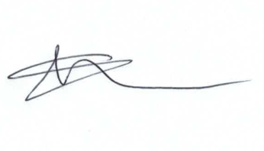
Current Committee:
Chris Rawlings(VC), Keith Bates, Caroline Brady, Glenn Mills, Matthew Harris, David Hill, Paul Walton, David West (Chair), Paul Sunners, John Martin,

