CHISELDON PARISH COUNCIL

Contact Clair Wilkinson – Clerk
Tel 01793 740744. clerk@chiseldon-pc.gov.uk

RECREATION & COMMUNITY COMMITTEE
meeting on Monday 21st August 2017 at The Old Chapel, Butts Road at 7.00pm

AGENDA
 |  | - Attendances and apologies for absence
 |  | - Declarations of interest
- Public recess
members of the public may address the Committee on any Recreation related matter for a maximum of five minutes
 |  | - Approval of minutes of meeting held on 17th July 2017
 |  | - Matters arising (not elsewhere on the agenda)/ Action points
 |  | - Football matters
 |  | - Tennis Club |  | Update after visit to Nationwide from Cllr Brady
 |  | - Castle View play area (CVPA) / teen area |  | Approve costs for new 2 rockers £1290.00 ex VAT for 2(£1548 with VAT) for delivery & installation from Creative Play UK. Horse and Motorbike rocker.
 |  | - Pavilion (items not addressed under Football matters)
 |  |  | - Recreation Ground
 |  |  | - Recreation Hall |  | Approve payment in principle for internal work to hall. Final costs to be approved by Finance Committee
 |  | - Youth activities
 |  | - Care of vulnerable people |  | Dementia safe place stickers – A community can place these in businesses/shops to show someone with dementia that they have a safe place to go to – does the committee want the Clerk to investigate further?
 |  | - Any other business

Date of next meeting: TBC 2017 at 7.00pm in The Old Chapel, Butts Road.

Signed: C. Wilkinson (Clerk)
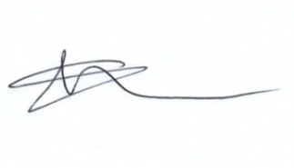
Committee Members: Paul Sunners (Chair), Paul Walton (VC), Glenn Mills, Keith Bates, Jenny Jefferies, Caroline Brady.

