CHISELDON PARISH COUNCIL

Contact details:
Clerk – 01793 740744 clerk@chiseldon-pc.gov.uk

Environment, General Purpose and Amenities Committee
meeting at the Old Chapel, Butts Road, Monday 18th March 2019 at 7.30pm

AGENDA
1. | Attendances and apologies for absence
2. | Declarations of interest
3. | Public recess
4. | Approval of minutes of meeting 18th Feb 2019
5. | Action points
6.  7.  8.  9.  10.  11.  12.  13.  14.  15.  16.  17.  18.  19.  20. | PARISHING PROGRESS  Settlement Boundary Review - update  Open Spaces Review - update  VILLAGE APPEARANCE  No issues  BUILDING & AMENITY PRIORITES  Review STORM quote for extended hire extinguisher service on 4 appliances – due every 4 years - £82.00 plus VAT  - TENNIS CLUB  - Tennis Club representative to update Committee  - Review issue with mud on courts – action required  - Review 2 quotes to repair flood lights on TC side of Hall and also request for new lights at their entrance gate. KT Electrical and STORM  PAVILION  Note - Damp in managers office being investigated – may need Handyperson to fix  ALLOTMENTS – Cllr Clarke to chair this item if needed.  For Info only -3 plots free still.  REC HALL, GROUND & CAR PARK  CCTV Quotes to be reviewed and decision taken if possible.  Review quote from STORM to remove dis-used water heater at Rec Hall – health risk. £65.00 plus VAT  - CVPA  No items  CEMETERIES  No items  COMMUNITY PRIORITIES  - FOOTBALL MATTERS  Club representative to update Committee.  - VULNERABLE PEOPLE AND BIOS  ITEMS FOR INCLUSION ON NEXT AGENDA  (Cannot be discussed or voted on at this meeting)
Next meeting: Monday 15th April 2019 at 7.30pm in The Old Chapel, off Butts Road

Signed: C Wilkinson (Clerk)
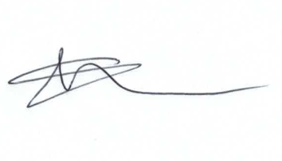
Current Committee:
Chris Rawlings (Chair), Caroline Brady, Keith Bates, David Hill, Andrew McDonald, Jenny Jefferies, Matt Clarke (Vice Chair), Paul Sunners, Paul Walton, Michelle Harris.

Additional Information

Note – Vertidraining of pitched has been carried out by Merretts.

Playground repairs and matting for new see saw has been done.

