CHISELDON PARISH COUNCIL

Contact details:
Clerk – 01793 740744 clerk@chiseldon-pc.gov.uk

Environment, General Purposes & Highways Committee
meeting at the CHAPEL, BUTTS ROAD, Thursday 13th July 2017 at 7.00pm

AGENDA

1. | Attendances and apologies for absence
2. | Declarations of interest
3. | Public recess
4. | Approval of minutes of meeting held 15th June 2017
5.  6.  7. | Matters arising not on the agenda  Action points  STORM facilities Management – Update on proposal for the Committee to review.
8. | Allotments | Final approval and vote of 2 x 6 foot water tanks at £97.22 each plus £200 labour costs plus delivery cost for allotments.
9. | Dog bins
10. | Highways
11. | Street furniture | Meadow Stores – using Parish bin for shop rubbish. Clerk has written to them to advise them to stop. What further action may the Committee need to take?
12.  13.  14. | Village appearance  Cemeteries & Chapel/Museum  Environmental Services | Parish Planters – final vote on design plan from Cllr Beaumont.  Update & vote on dealing with overgrown hedge cutting costs for a resident so Albuild can manage the grass verge underneath. There have been complaints about the overgrown nature of the area.  Discussion and vote of approval of releasing funds to organise some road sweeping by Allbuild. Priority roads to be identified and suggestions brought to meeting.  Need to deal with dog that comes into cemetery and makes a mess.  Approval of extra £100 (approx.) expenditure on damp proof layer for Chapel carpet. Vote needed.  Museum has requested air vents in the walls to help with condensation. Allbuild have quoted £200 with parts & VAT to do this. Vote needed.  2 trees need work in cemetery – Morgan Trees have quoted £180.00 per tree (No VAT)  Discussion & Vote on using Chapel as book exchange location – run by volunteers.
15. | Any other business

Next meeting: Thurs 17th August 2017 at 7.00pm in The Old Chapel, off Butts Road

Signed: C Wilkinson (Clerk)

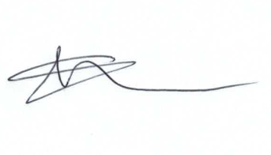
Current Committee:
Chris Rawlings(VC), Keith Bates, Caroline Brady, Glenn Mills, Matthew Harris, David Hill, Paul Walton, David West (Chair), Paul Sunners, John Martin,

