CHISELDON PARISH COUNCIL

Contact details:
Clerk – 01793 740744 clerk@chiseldon-pc.gov.uk

Environment, General Purposes & Highways Committee
meeting at the RECREATION HALL OFF NORRIS CLOSE, Thursday 11th May 2017 at 7.00pm

AGENDA

1. | Attendances and apologies for absence  Vote in New Chair of Committee and New Vice Chair
2. | Declarations of interest
3. | Public recess
4. | Approval of minutes of meeting held 13th April 2017
5. | Matters arising not on the agenda  Action points
6. | Allotments | Discussion & vote on proposed new water tank for allotment.
7. | Dog bins
8. | Highways | Request from resident to write to Mr Margesson about tractor speed in the village.
9. | Street furniture | Residents request for consideration for old railway signal machinery to be installed on New Road near allotments – historical feature – perhaps for next financial year?
10.  11.  12. | Village appearance  Cemeteries  Environmental Services | Chapel Update  Grass cutting at Strouds Hill update if required.
13. | Any other business | Review and approve Terms of Reference document for the Committee (Clerk to circulate via email)

Next meeting: Thurs 15th June 2017 at 7.00pm in The Old Chapel, off Butts Road

Signed: C Wilkinson (Clerk)

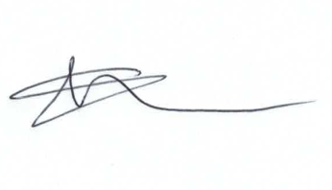
Current Committee:
Chris Rawlings(Chair), Keith Bates, Caroline Brady (vc), Glenn Mills, Matthew Harris, David Hill, Paul Walton, David West, Paul Sunners, John Martin,

