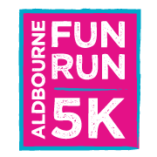

Aldbourne village is excited to be hosting a 5k Fun Run again, after a break of several years, ‪on Sunday June 11th at 10am.

It is being organised in aid of St Michael’s School, which has just been awarded Ofsted Outstanding, to raise much needed funds for building work for its current pupils.

The run will start and finish on the village green, it will be varied, offering a little tarmac but predominantly beautiful tracks and footpaths in the farmland surrounding the village. You can run it, walk it, push your (cross-country style) pushchair or walk your dog along it and you are encouraged to come along whether you are a child or adult! Every single person who finishes the course will be presented with a medal and a goody bag, plus t-shirts will be available both at online registration and (a few) on the day.

Bacon butties and hot drinks will fuel you or your support team before the race and burgers and cakes will be available afterwards. There will even be a photographer be present to capture those heroic moments of completing a great event and photos will be available to purchase online the next day.

You can sign up now at www.aldbourne5kfunrun.co.uk or for further information and details of how to pay by cash or cheque by emailing aldbourne5kfunrun@gmail.com. We can’t wait to see as many of you as possible either participating or supporting on the day!

