HAPPY NEW YEAR FROM THE WASHPOOL TEAM (INCLUDING THE SHEEP)!

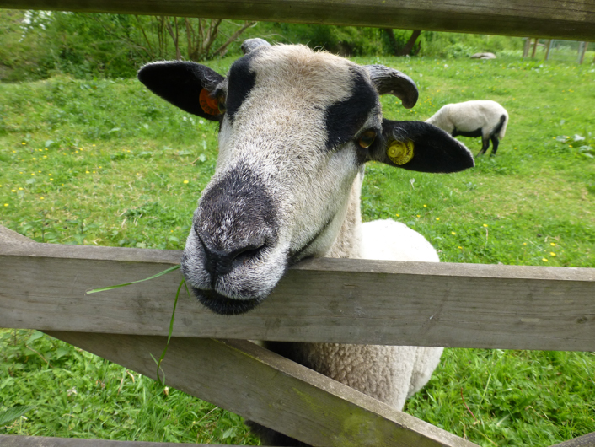

By the time you read this we hope you will have enjoyed a happy and peaceful Christmas. We have big plans for the Washpool in 2017 (with several special projects on the cards) and we hope you’ll join in - either by coming along to one of our conservation days or by joining our new friends scheme when it launches in the spring.
As a reminder, the Washpool Conservation Days will take place between 10am and 3pm on the following Sundays:
15 January
19 March
21 May
16 July
17 September
19 November

No special knowledge is required and we also provide all of the necessary tools.
Thanks once again for all your support
WARP

