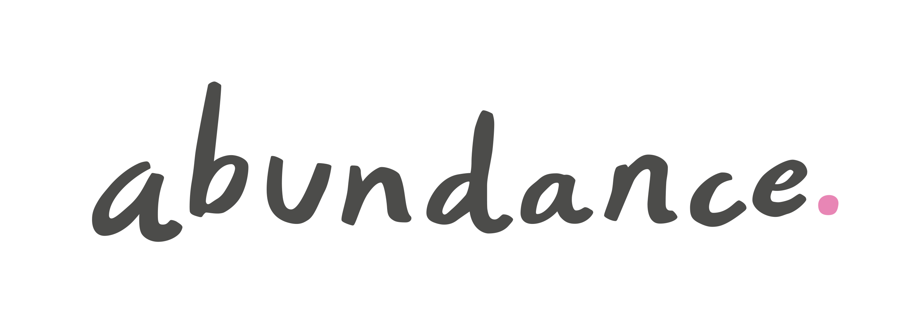

FOR IMMEDIATE RELEASE

Last chance for investors to benefit from ‘early bird bonus’ for Swindon Council Solar Bonds

- UK’s first Council Solar Bonds get off to great start, with over a third of investment achieved within the first month.
- Swindon residents show strong support for the project, with over 300 local people opening accounts with Abundance.
- “Early bird bonus” of 0.5% for the first five years ends on April 11th

4th April 2016 The UK’s first ever Council Solar Bonds, launched just five weeks ago by Swindon Borough Council and leading peer-to-peer investment platform Abundance, have got off to a very strong start.

The bonds have already attracted over £ 727,000 in investment which represents 41% of the total amount of £1.8m available to small investors. The Council will also be investing £3m, with proceeds of the bond offer used to fund construction of the Swindon Community Solar Farm at Common Farm, Wroughton.

The Bond offers people living in the Swindon area and further afield the chance to earn a bank-beating effective rate of return of 6% over its 20-year term, while benefiting from the lower risk inherent in investing alongside Swindon Borough Council. Investments start from just £5 and an “early bird bonus” of 0.5% for the first five years will boost returns for those investing before April 11th.

Bruce Davis, Managing Director of Abundance, said: “Swindon Council Solar Bonds have been one of the most popular investments we’ve launched on Abundance, and we’re really pleased with the enthusiastic response we’ve had from local investors, with over 300 people from the Swindon area opening accounts with us so far. It proves there’s a local appetite for investments that offer a benefit for the community as well as a good financial return. I would urge anyone thinking of investing not to delay if you want to take advantage of our early bird bonus, which expires in a week.”

The bonds are currently being promoted throughout the Swindon area with Abundance’s characteristic pink advertisements appearing at the train station, on roadside hoardings and in local press. Swindon Borough Council has also advised local residents about the investment opportunity through its council-tax leaflet which has been delivered to most of the households in the town.

Helen Browning, President of the Soil Association and a Swindon resident, said: “You can’t be anything other than enthusiastic when local government starts to take an active interest in green energy, alongside other environmental affairs. It’s an urban-based borough council in Swindon, of course, and people like us at the rural margins probably get a little bit forgotten in our efforts to make things a bit more environmentally lovely, which is what we try to do in all our activities. But everyone’s got to start somewhere and Swindon’s Solar Bonds seem like a great way to engage local people with the benefits of renewables.”

A Community Interest Company, wholly owned by Swindon Borough Council, would own and manage the solar farm. Revenues will be raised from selling the electricity generated, as well as support from the Feed In Tariff subsidy (FIT). The solar farm was pre-accredited for the FIT before government policy changes at the start of the year, so revenues are guaranteed by the government for 20 years. Sixty-five per cent of the distributable profits from the solar farm will go towards funding local community initiatives, with the remaining 35% going to the Council.

The bond offer will remain open for investment until 30th June. Investing is quick and easy via the Abundance website, www.abundanceinvestment.com/Swindon .

-ends-

Media contacts

Abundance: Sophy Fearnley-Whittingstall on 07979 368238 sophy@sfwcommunications.co.uk

Notes for Editors

About Swindon Community Solar Farm:
A Community Interest Company, wholly owned by Swindon Borough Council, will manage the solar farm. It will cost £4.8m to construct, with £3m coming from the council’s investment and the remaining £1.8m from small investors locally and across the country. The Bonds are provided in partnership with Abundance Investment, which has successfully raised £16.5m for 17 different renewable energy projects in the past three years.

The solar farm will be on council-owned land at Common Farm near Wroughton and has been developed by Public Power Solutions (a wholly-owned subsidiary of Swindon Borough Council), who structured the blend of public sector and community investment. It was given planning consent though Swindon Borough Council’s use of Local Development Orders, which speed up the planning process but still allow full public consultation.

Construction is due to begin in spring this year. The site will be managed to promote biodiversity, with the land around the panels remaining in agricultural use, with sheep grazing for part of the year.

The solar farm will have a capacity of 4.8MW and will generate enough electricity to supply the equivalent of 1200 typical homes and save around 2000 tonnes of carbon dioxide a year.

About Abundance:
Abundance is a leading direct investment platform that is putting people in control of their money. People invest in individual projects that generate something good for the environment and society as well as bank-beating returns.
The investor chooses which projects or project to invest in from just £5 and benefits from a long term financial return, while the world benefits from clean energy generation.

Since launching in 2012 more than 2,200 people have invested £16.5m directly into the projects they support. In the process, Abundance has achieved a number of firsts. As well as being the world’s first FCA-regulated peer-to-peer investment company, it is also the first investment platform to offer a dedicated peer-to-peer investment SIPP and will be launching the UK’s first innovative finance ISA for renewable energy investments on April 6th 2016.

Abundance and Abundance Investment are trading names of Abundance NRG Ltd which is authorised and regulated by the Financial Services Authority (no. 525432).

About Council Solar Bonds:
A bond (also known as a debenture) is an official IOU issued by a company which offers a fixed rate of return over a defined period. Swindon Solar Bonds are peer-to-peer investments which are a regulated investment and can be traded. In this case, the Community Interest Company will be owned by Swindon Borough Council.

As with any investment product there are risks. Part or all of the original invested capital may be at risk and any return on the investment depends on the success of the project invested in. Investors should be prepared to hold Abundance investments for their full term, and many will have terms of more than 15 years. Abundance investments may not be readily realisable (and their value can rise or fall). They may be secured or unsecured, and where they are secured this does not ensure repayment. Estimated rates of return can be variable and estimates are no guarantee of actual return. Specific risks will apply in relation to each product. All risks should be considered before an investment is made and the Offer Document for each investment should be read.

