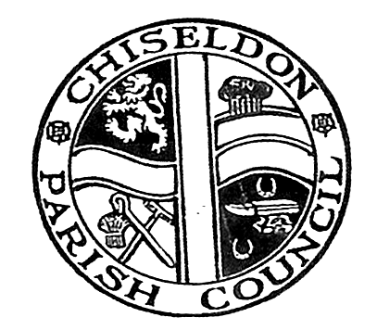

Chiseldon Parish Council

Precept Increase 2016/17
Frequently Asked Questions

Q: | Who are Chiseldon Parish Council? Why do they appear on my Council Tax Notice?
A: | Chiseldon Parish Council are a civil local authority (or first tier of local Government) that covers the Civil Parish of Chiseldon which includes the villages of Chiseldon, Badbury, Hodson, Draycott Foliat and Badbury Park. The council itself is made up of 15 elected Parish Councillors and is supported by a Parish Clerk.
Q: | What does Chiseldon Parish Council do?
A: | The parish council works alongside the Borough Council on a number of issues, for example: Highways, Planning and Environment matters. In addition, we provide extra services such as a Cemetery, Allotments, some Youth Services, a Recreation Hall and a Sports Ground. We also provide help and support to the local community through small grants and donations.
Q: | Why are you increasing your portion of my Council Tax Bill by 100%?
A: | Historically the Parish Council has worked hard to maintain our precept level at the same rate year on year. The last time the precept was adjusted was over ten years ago, a record which we are proud of.  After reviewing our planned expenditure for 2016/17 it became apparent that it was no longer feasible to maintain our precept at the current rate and to accommodate planned expenditure, special projects from our Environment and Recreation committees and potential future liabilities such as repairs to our Recreation Hall and Chapel building, an increase was unavoidable.  We estimate that the increase will equate to approximately 63 pence per household per week in the parish – less than a cup of coffee – which still represents value for money.
Q: | Councils aren’t allowed to increase council tax by more than 2% without a referendum – when can I vote?
A: | The “2% rule” applies to the Primary Local Authority, which in this case is Swindon Borough Council. It does not apply to Parish and Town Councils and the increase has been agreed by the elected officers of the Parish Council.
Q: | I heard something about a vote in Stratton St Margaret – is this related?
A: | Swindon Borough Council are approaching Parish and Town Councils to see if they would like to consider taking on responsibility for some non-essential services such as grass-cutting, hedge maintenance and litter clearance to help alleviate some of their budgetary pressures and to maintain quality of service. Stratton St Margaret Parish Council put the concept to a vote; the outcome of which was not in favour of providing these services. Chiseldon Parish Council is still considering its position.
Q: | I want to talk to someone about this increase. Who do I contact?
A: | In the first instance, please contact the Parish Clerk at clerk@chiseldonparishcouncil.com or feel free to attend one of our meetings which have a dedicated public recess. Details of the times and venues of such meetings can be obtained from the clerk or from our website.

